Physics 11
Work & Power Worksheet
- Calculate the work done on moving a 25 kg box a distance of 3.7 m by an applied horizontal force of 65 N. Calculate the power if this is done in 13 s.
65 N

3.7 m

- A 125 kg sled is lifted to the top of a 23 m high hill.
  - What is the work done in lifting the sled?
  - A time of 15.9 s is required to lift the sled to the top of the hill. How much power does this require?

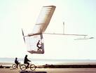
- In 1979 the human powered Gossamer Albatross flew across the English Channel. The pedaling pilot averaged 190 W over the distance. If the pilot’s power was used to lift a 110 kg mass, to what height would he lift the mass in a time of 25 s?

- A 2.5 hp (1 hp = 744 W) motor is used to power a hoist to lift a 1700 kg car 1.86 m above the garage floor.

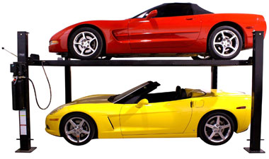
  - How much time does it take the hoist to lift the car?
  - The hoist slowly lowers the car back down to the ground. How much work does the hoist motor do in lowering the car?

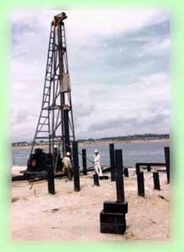
- A pile driver is used to drive large piles in to soft ground to create a solid foundation for a building. The pile driver has a mass of 450 kg and is lifted to a height of 2.5 m above the pile and is then allowed to fall striking the pile. The ground offers a resistance of 2.0 x 10⁵ N of force against the push of the pile.
  - How far does the pile drive push the pile into the ground with each strike?
  - How many strikes would the pile driver have to make to drive 50 piles 7.5 m into the ground?

- Many mountain roads are built so they spiral around the mountain rather than go straight up towards the peak. Explain why such a spiral design is beneficial for vehicles? (Hint: Consider the power expended vs the work)

- A 1500 kg car accelerates from rest to 10.0 m/s in 3.00 s.
  - Find the work done on the car in this time period.
  - Find the average power delivered by the engine in this time interval.

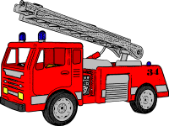
- In fighting a fire a pumper fire truck must be able to list 18000 kg of water to a height of 27 m in a time of 35 s. What is the power of the pump in the fire truck pumper?

- A 500 hp Mustang is able to push this 1750 kg car down a 410 m drag strip in a time of 11.5 s.
  - What is the work done by the car?
  - How large is the average force during the car’s motion?
Answers: 1. 240.5J, 18.5W 2. a)2820J b)1772W 3. 4.4m 4. a)17s b)-31000J 5. a) 0.055m b) 6803 strikes 7. 75000J, 25000W 8. 1.4×10⁵W 9. a)4.28×10⁶J b)10400N

