Physics 11

Work, Energy, & Thermal Energy Review WS

- A 23 kg boulder is pushed a distance of 4.5 m by a horizontal force of 35 N. How much work was done on the boulder?

- A 650 kg pile-driver is lifted a height of 4.0 m before being dropped onto a pile. The pile is pushed into the ground a distance of 0.050 m every time the pile-driver is dropped.
  - How many times must the pile-driver be dropped to push the pile 3.0 m into the ground?
  - What is the ground resistance force on the pile?

- A 2300 kg car whose motor is rated at 45000 W completes a 200 km road race in 8280 s. How much work is done during the race?

- Tim lifts a 34 kg weight to a maximum height of 2.3 m and then slowly lowers the mass to the floor. He repeats this motion 15 times to build up his muscles.
  - What total work is being done?
  - Tim does this motion in 46s. What power does Tim generate?

- An oil pump delivers 450 kg of oil up to a platform 35 m above the ground in a time of 23 s.
  - Calculate the work done on the oil.
  - Calculate the power produced by the pump.

- A boat is pushed through the water at a constant speed of 16 m/s while the motor generates a constant force of 7.0 x 10³ N. What power does the motor develop?

- A 45 kg climber is able to lift her body to a vertical height of 450 m. The she lowers herself down to a height of 250m.
  - How much potential energy does she gain in climbing 450 m?
  - How potential energy does she lose on the way down to the 250 m mark?

- A 2300 kg car is travelling at 18.0 m/s. What is the car’s kinetic energy?

- A 25 kg cart is moving with a speed of 6.4 m/s down a level hallway. A constant force of –10.0 N acts on the car slowing it to 2.2 m/s.
  - What is the change in kinetic energy of the cart?
  - How much work is done on the car?
  - How far did the cart move while the force acted?

- Tarzan swings from the top of cliff using a long rope-vine. The 15 m long vine is horizontal when Tarzan jumps off the cliff. What is the speed of Tarzan at the bottom of the swing?

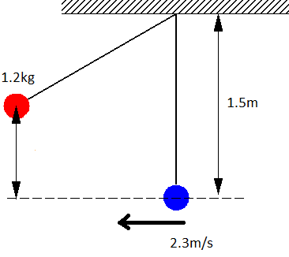
- A pendulum is swinging back and forth. Its velocity at the bottom of its swing is 2.3m/s.
  - How high does the pendulum go?
  - What angle does the pendulum make to the vertical axis when it is at its highest point?

- A 450 kg roller coaster reaches the top of the first 78 m high hill with a speed of 11 m/s. (Assume no friction)
  - What is the speed of the roller coaster car at the bottom of this hill?
  - The car then climbs up the next hill and reaches its peak with a speed of 19 m/s. How high is this hill?

- A 0.0025 kg bullet travelling at 450 m/s strikes and embeds itself into a 6.7 kg sand bag.
  - What is the kinetic energy of the bullet before it hits the sand bag?
  - What kind of collision is this? (think of momentum)
  - What is the speed of the sand bag & bullet after collision? (think of momentum)
  - What is the kinetic energy after the collision?
  - How much energy was “lost”?
  - What happened to the “missing” energy?

- Which of these objects contains the most heat energy. Explain your answer.
  - 120 kg of water at 20 ºC
  - 9.0 kg of water at 80 ºC
Heat Capacities
- Iron 450 J/kg*K
- Brass 380 J/kg*K
- Water 4180 J/kg*K
  - 50 kg of copper at 47 ºC

- Convert:
  - 230 K to ºC
  - –67 ºC to K
  - 670 ºC to K
  - 980 K to ºC

- A 23 kg piece of iron is heated up from 150 ºC to 750 ºC. How much thermal energy does this take?

- A 2.3 kg piece of brass is heated to 67 ºC and is then immersed into some water initially at 20 ºC. The brass cools down to 29 ºC. What was the mass of the water was used in this process?

- A 400 W electric immersion heater is used to heat a 250 g of water. The water is initially at 20 ºC. This process takes 120 s. What is the final temperature of the water?

- A 45 kg piece of iron is heated to 95 ºC and is then placed into 120 kg of water initially at 20 ºC. What is the final temperature of the water?

- A soft drink from Canada is labelled “Low Joule Cola”. The label says 100 mL yields 1.9 kJ. The can contains 375 mL. Jennifer drinks the whole can of cola and then wants to “burn off” the energy from the drink by climbing stairs. How high must she climb if she has a mass of 65 kg to “burn off” all of this energy given that the human body is about 25% efficient? (Assume 1.0 mL of Cola has a mass of 1.0 g)
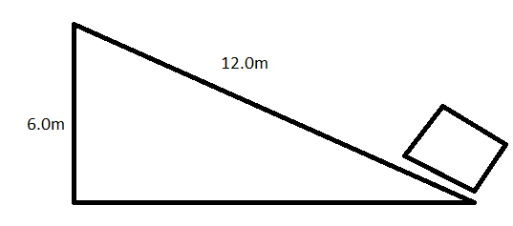
- A 7kg box is pushed up the ramp shown in 3.25s. If it requires a force of 40.0N to push it at a constant velocity, what is the efficiency of the ramp?

- A 1300W electric motor is used to lift a 78.0kg mass to a height of 4.0m in 3.10s. What is the efficiency of the motor?

- A gasoline car engine is usually 30% efficient or worse.
  - Calculate the energy required to bring a car 1400kg from 0km/h to 100km/h in 6.00s.

  - What volume of gasoline is required to run this car if gasoline has an energy density of 34.2MJ/L.

  - An electric car generally has an efficiency of 80%. How much energy do does a 1400kg electric car require to go from 0km/h to 100km/h in 6.00s?

  - Power plants that run on fossil fuels typically have an efficiency of 45%. What volume of gasoline will have to be burned to power this car?

- A pulley has an efficiency of 85.0%. If 600J are exerted to lift a 18.0kg mass. How high is the weight lifted?

