Vector Subtraction (“Change in” vectors)

Vector subtraction occurs when we are looking for the change from one vector to the next.

Remember:

To solve a vector subtraction, or to find the change between two vectors:

Use the “____________________________” method

BUT

the subtracted vector is _______________________________

Examples:

- Find the change between the velocity vectors:

a) With a vector diagram only b) Solve for the change as a number with direction
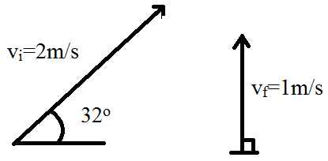
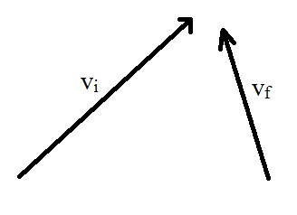

Jim is initially biking 3m/s East but turns a corner and is now biking at 4.3m/s at 21° East of North. What is Jim’s change in velocity?

Relative Velocity

Each object has its own reference frame, and other things will move relative to that object.

A common example is a boat which is moving on a river, which has a current relative to an observer standing on the shore. This relative motion follows the Principle of Superposition

Principle of Superposition:

Examples
- A motorboat traveling 4 m/s, East encounters a current traveling 7.0 m/s, North.
  - What is the resultant velocity of the motorboat?
  - If the width of the river is 80 meters wide, then how much time does it take the boat to travel shore to shore?
  - What distance downstream does the boat reach the opposite shore?

- An airplane flying at 33m/s must move due North to reach its destination. If a tailwind is blowing at 12m/s at 24° South of West, what heading must the plane make?

