Equilibrium – Balancing Torques Lab

Purpose:
The objective of this experiment is to learn to measure torque due to a force and to adjust the magnitude of one or more forces and their lever arms to produce static equilibrium in a meter stick balanced on a knife edge; use the conditions for equilibrium to determine the mass of the meter stick and the mass of an unknown object.

Equipment
- Meter stick
- Knife edge
- Known masses of varying values
- Unknown mass
- Balance

Procedure
There are three parts to this experiment:
- You will balance three forces on a meter stick and show that the net torque is zero when the meter stick is in equilibrium.

- You will balance the weight of the meter stick against a known weight to determine the mass of the meter stick.

- Finally you will use the principle of rotational equilibrium to determine the mass of an unknown object.

All lever arm distances are measured from the fulcrum, which also serves as the point of support. You will be using string to hang the weights on the meter stick. Assume that the mass of the string is negligible.

Procedure A: Balancing Torques
- Balance the meter stick on the apparatus. The point at which the stick balances is the center of gravity of the meter stick. Enter this value on the worksheet.

- Select two 200-gram masses and one 100-gram mass.

- Refer to Figure 1.
  - Place m₁, a 200 g mass, at x₁, 35cm from the fulcrum.

  - Place m₂, a 100 g mass, at x₂, 15cm from the fulcrum
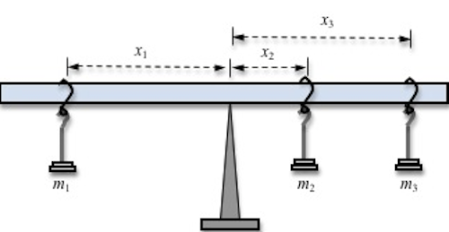
Figure 1: Three balanced torques

- Enter these values in Data Table 1. Calculate the torques due to m₁ and m₂. Calculate the predicted value that distance that x₃ should be for the meter stick to balance.

- Place m₃ on the beam and adjust it until the meter stick is balanced. Record this value.

Procedure B: Finding the Mass of a Meter Stick
For this part of the experiment you will use a 200-gram mass, the meter stick and the balance apparatus.
- Move the apparatus to the 25-cm mark. You will notice that the meter stick is no longer in equilibrium. The unbalanced force is the weight of the meter stick acting at its center of gravity.

- Experimentally find the position (called x₁) of the 200-gram mass, needed to balance the meter stick. Enter the value of x₁ on the worksheet.

- In the space provided on the worksheet, sketch and carefully label a diagram of the meter stick and the 200-gram mass. Show all the torque-producing forces. Remember that the weight of the meter stick acts at its center of gravity. Indicate on your diagram the directions (clockwise or counterclockwise) of each torque.

- Calculate the torque due to the 200-gram mass and enter this value in Data Table 2.

- Use the value of the torque due to the 200-gram mass and the conditions for rotational equilibrium to determine the torque due to the mass (called m₂) of the meter stick. Enter this value in Data Table 2.

- Use a balance to measure the mass of the meter stick, this will be your predicted value for the mass of the meter stick.

Procedure C: Determining an Unknown Mass
- Position the center of gravity of the meter stick over the support.

- Place a 50-gram mass (m₁) at the 70-cm mark. and a 200-gram mass (m₂) at the 20-cm mark.

- Take a random small object you will be able to suspend with string. Balance the meter stick using this object.

- In the space provided on the worksheet, sketch and carefully label a diagram of this set-up. Show all the torque-producing forces. Indicate on your diagram the directions (clockwise or counterclockwise) of each torque.

- Calculate the torques due to m₁ and m₂,and enter these values in Data Table 3.

- Use the values of the torques due to the two masses and the conditions for rotational equilibrium to determine the torque due to m₃. Enter this value in Data Table 3.

- Determine the experimental mass of m₃.

- Use the balance to determine the predicted mass of the third object.

