Name: ______________________________ Date: ____________ Block: _____ Score: ____ / 8pts

WOOLYBOOGER LAB – Which Beak is Best?

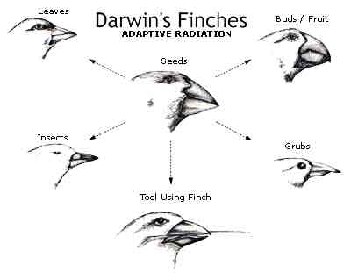
Background: You and your team are crewmembers on the Beagle in 1831. Darwin has asked your team to assist him in collecting data on a strange and unusual bird that he has discovered on the Galapagos Islands. He has called this bird the woolybooger. Darwin and your team search the islands and find three different populations of this creature. During your observations of these three populations, you discover that each group is similar in appearance except for mouth variations. Some woolyboogers have a knife-shaped mouth, some have a clip-shaped mouth, and some have a tweezer-shaped mouth. All of the birds have migrated to an island that only has dried beans for them too eat and the hours of daylight needed for finding food is steadily decreasing due to the change in seasons.
Darwin and your team study the woolybooger’s life on the Galapagos Islands. During your last few months on the islands, you discover a new rare woolybooger, which has a spoon-shaped mouth. On the Beagle, Darwin and your team discuss which beak type of woolybooger will survive the best on the island and how the population of woolyboogers will change over time or evolve.

MATERIALS:

dried beans
knives
binder clips
tweezers
spoons
paper plate (1 per group)
cups (1 per person)

PROCEDURE:
- You will run through five trials of feeding by the woolyboogers. You will be assigned a feeding tool to gather your favorite food, beans. You must use your utensil as demonstrated to capture food. You cannot scoop the beans into the cup, which represents your stomach. You must lift the beans, one or two at a time, with your utensil. The cup must stay in your hand during feeding.
- You will be required to capture at least 20 beans in a trial in order to survive. If 20 beans are not captured, your woolybooger has died. When a woolybooger dies, in the next trial you will play the role of the offspring of the most successful surviving woolybooger (the woolybooger capturing the most beans).
- The first trial will last 1 minute 15 seconds, the second 1 minute, the third 45 seconds, the fourth 30 seconds and the fifth will be 15 seconds. The teacher will time the class.
- Because woolyboogers with spoon-shaped mouths are rare, only a few of you will be assigned this tool for the first generation of woolyboogers.

Hypothesis: Which beak do you think will work best? How do you think the woolybooger population will change over time (evolve)?
______________________________________________________________________________

______________________________________________________________________________

DATA TABLE:
 | Number of woolyboogers at beginning of each trial
Mouth shape | 1 minute  15 seconds | 1 minute | 45 seconds | 30 seconds | 15 seconds | Final  Number
Knife

Clip

Tweezer

Spoon

Part 2 – Adaptive Radiation

PROCEDURE:

- Start by choosing a type of beak. You are free to choose any type of beak you want.
- Your plate will now have an assortment of different food available on the plate: beans, elastic bands, toothpicks and macaroni.
- You will be required to capture 20 pieces of food to survive. If you do not survive, then you will be required to choose a new type of beak for the next generation.
- Each trial will last 30 seconds.
- At the end of each trial the food supply will replenish. Only 20 new pieces of each type of food can be added to the plate.

Hypothesis: Which beak will work best? How will the woolybooger population change when there is a varied food supply?

__________________________________________________________________

 | Number of woolyboogers at the beginning of each trial
Mouth Shape | Trial #1 | Trial #2 | Trial #3 | Trial #4 | Trial #5 | Final Number

APPLICATION QUESTIONS: (answer in complete sentences)

1. Describe how the woolybooger population evolved (changed over time)? How did this compare to your hypothesis from before we ran this simulation? (at least 3 sentences)

2. Which variation of woolybooger beak was best adapted to survive on the island? Why? What happened to the woolyboogers who were less adapted to survive on the island?

3. What would be necessary in nature for all the variations of woolyboogers to be able to coexist and all reproduce without one beating out another?

4. What is a real-life example of the woolybooger, where one organism has a definite advantage over another organism of the same species? Explain.

5. In what ways was this simulation realistic?

6. In what ways was this simulation unrealistic?

7. How could this activity be improved or expanded upon to make it more realistic?

8. What do you think were the big ideas to be learned from this activity?

