Equilibrium – 3 – Torques Not at 90°

Consider a wrench attempting to turn a nut on a bolt.

How will the wrench move when…
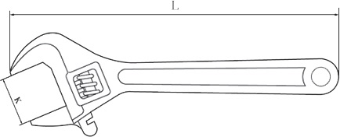

We can note that only the _______________________________________ component of the force provides any rotational motion.

Ex. Determine the length of the 6.4kg beam if the tension in the cable is 88N.
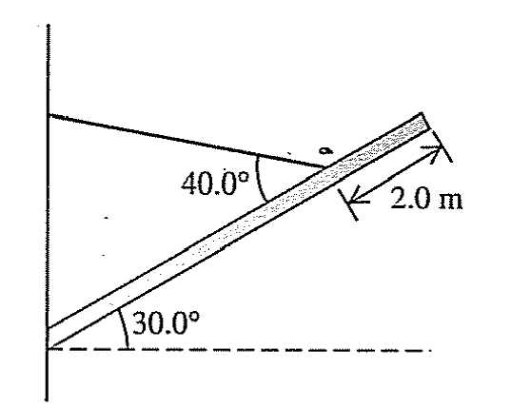
Ex. Determine the tension in the cable if the beam has a mass of 2kg.
