Ray Optics Review

Describe the Properties of the Types of Media
- Transparent

- Translucent

- Opaque

Shadows
Use ray diagrams to find the shadow in the two situations
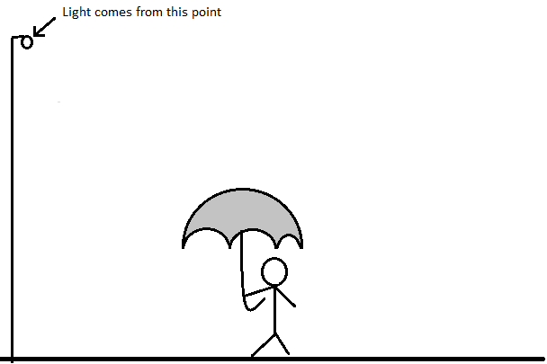

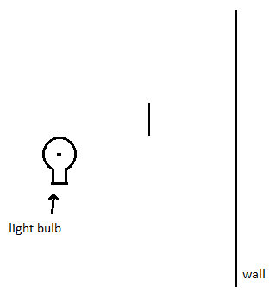

Reflection
State the Law of Reflection

Plane Mirrors
- The reflected image is (bigger/ same / smaller) size as the object

- The reflected image is a (bigger/ same / smaller) distance than the object from the mirror.
- ________________ is flipped

Concave Mirrors
Light rays _________________
Draw parallel light rays striking a concave mirror:

Concave mirrors are used for:

Convex Mirrors
Light rays ____________________
Draw parallel light rays striking a convex mirror:

Convex Mirrors are used for:

Refraction
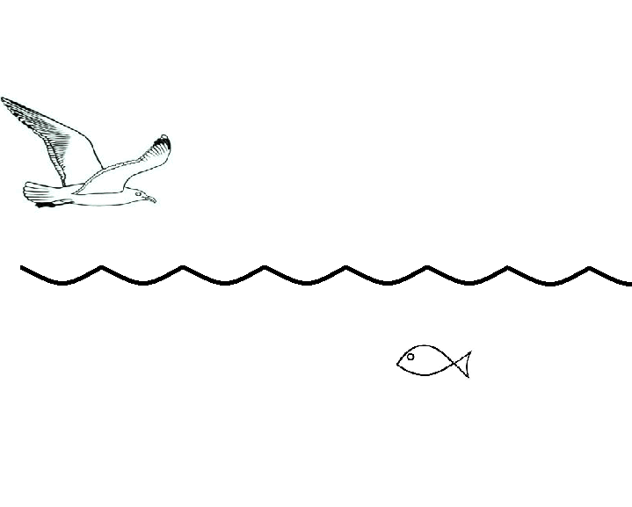
Draw the light rays showing the refraction that occurs with the bird looking at a fish:

Concave Lenses
Light rays ______________
Draw parallel light rays passing through a concave lens:

- Concave lenses are used for:

Convex Lenses
Light rays ________________
Draw parallel light rays passing through a convex lens:

- Convex lenses are used for:

When light travels into a denser material, it will move slower. What happens to the direction it is travelling?

When light travels into a less dense material, it will move faster. What happens to the direction it is travelling?
Use a Ray Diagram to show how the letter will look using a Pinhole Viewer:

Waves
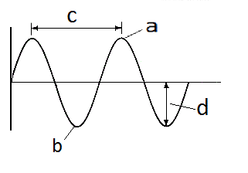
Label the parts of the wave

Name the two different types of waves.
-

-

Jim counts 42 waves occurring in 15 seconds. What is the frequency of the waves?

Jessica is making a wave with a frequency of 35Hz. How many waves is she making each second?

Bob is in a boat. It rises 6m when it travels from the trough to the crest of the water waves he is on. What is the amplitude of the water waves?
Extra Review p.198

