Energy Skate Park Simulation

Open the Energy Skate Park Basic at https://phet.colorado.edu/en/simulation/energy-skate-park-basics.

Go into Playground mode (button at the bottom) and pull the friction slider to None. Set up some track and play around with the simulation, become familiar with the layout. Then answer the questions below.

Questions:
- Set up a U shaped track. How high does the skater go compared to the height he started at? (Use the pause button and the grid to help you determine this)

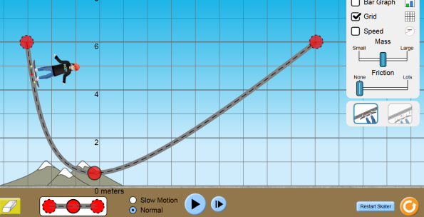
- Drag one end of the track so it has a steep slope and a gradual slope. How does this affect the height reached by the skater?

- Click the Bar Graph option. As the skater moves back and forth, what can you say about his amount of:
  - Potential Energy

  - Kinetic Energy

  - Total Energy

- Reset the skater and increase the amount of friction. What type of energy does friction generate?

- How does the generation of friction affect:
  - The speed of the skater at the bottom of the track?

  - The height reached by the skater on the opposite side of the track?

  - The total energy of the skater?

- Build a track and let the skater follow it. If the skater hits the ground hard, what type of energy is generated?

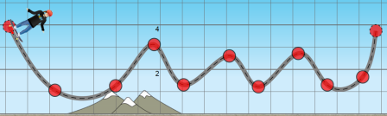
- Build your own track (one where the skater doesn’t smash into the ground). Sketch your track on the paper. Turn Friction back to NONE. Turn on the energy Pie Chart and Bar Graph.
  - At four different points along your track, sketch the bar or pie graph of the skater’s energy.
  - Reset the skater and add a little friction. Sketch the new pie graphs for the same 4 points of your drawing.

Conclusion:
What can you conclude about the total amount of energy in a system that has:
- No Friction?

- Friction?

