Potential Energy Worksheet
(Use the GUESS method, Show all work, Include units)

EXAMPLE
A 30 kg child climbs 15 meters up a tree. When he look arounds, what is the child’s potential energy?

STEP 1. First we identify the Given information provided in the problem:
• mass = 30 kg
• height = 15 meters
STEP 2. Identify the Unknown information:
• weight
• potential energy
You should note that you are not given the weight of the child, but rather the mass. To solve this problem, you must convert the child’s mass to his corresponding weight on Earth.
• weight = mass x gravity • weight = 30 kg x 9.8 m/sec2 • weight = 294 N
STEP 3. Identify the Equation
• PE = weight x height
STEP 4. Now, Substitute the information for weight and height into the gravitational potential energy formula:
• PE = 294 N x 15 meters
STEP 5. Solve the problem to give a potential energy value of 4410 J.

- A weight lifter lifts a set of 1250kg weights a vertical distance of 2m in a weight lifting contest. What Potential Energy do the weights now possess?

- A shopper in a supermarket takes a box of sugar from a shelf that is 1.5 m high because he is going to bake some muffins. He also needs to get some blueberries. The sugar has a weight of 5N. What Potential Energy did the sugar have before it was taken from the shelf?

- If 2 J of work is done in raising a 180 g red delicious apple to bring it to your mouth to take a bite of the apple, how far is it lifted?

- A baby carriage that is carrying twins is sitting at the top of a knoll that is 21 m high. The carriage with the babies are 48kg. What is the Potential Energy of the twins and the carriage?

- There is a elephant shaped weather vane at the top of a corn dryer tower that is 45 m high. If the weather vane weighs 190 N, what is the Potential Energy that the weather vane has?

- A snowball that will be used to build a snowman is at the top of the only hill in town and weighs 22N. If the Potential Energy of the snowball is 520 J, what is the height of the snowy hill?

- A Cessna 172 plane that is used to transport up to four VIP's is 2 km in the air. If the Potential Energy of the VIP plane with three VIP's onboard is 8.60×10⁷ J, what is the combined mass of the Cessna and passengers?

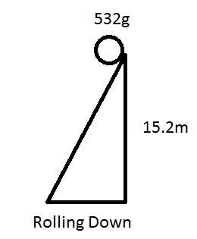
- The balls are rolling up or down the slopes at a constant velocity. Calculate the work done on each ball when it gets to the top/bottom of the slope.

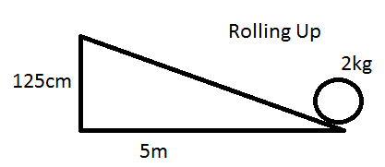

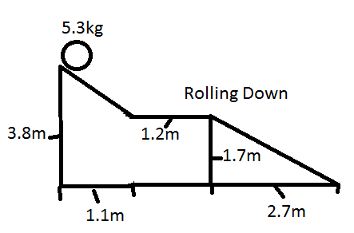

- Steve is moving from his 2nd floor apartment. He lifts a 5kg box 0.5m up, off the floor, then walks 13m west to the stairs. He walks 3.3m down the stairs then walks 22m south to the truck. He steps up 0.3m to get into the truck and puts the box down 0.5m to sit in the bed of the truck. How much work was done to the box? (Hint: What was the box’s change in gravitational potential energy?)
1. 24500J 2. 7.5N 3. 1.13m 4. 9900J 5. 8550J 6. 24N 7. 4.39×10³kg 8. 24.5J, -79.2J, -197J 9. -147J

