CONCEPTUAL QUESTIONS

NEWTON’S FIRST LAW

- If you were in a spaceship and fired a cannonball into space, how much force would have to be exerted on the ball to keep it moving once it has left the spaceship?

- Many automobile passengers have suffered neck injuries when struck by cars from behind. How does Newton's law of inertia apply here?

- How do headrests help to guard against this type of injury?

- Suppose you place a ball in the middle of a wagon, and then accelerate the wagon forward. Describe the motion of the ball relative to the ground.

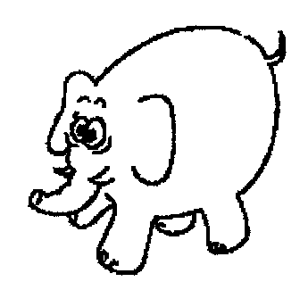
- Describe its motion relative to the wagon.

- If an elephant were chasing you, its enormous mass would be most threatening. But if you zigzagged, its mass would be to your advantage. Why?

- Two closed containers look the same, but one is packed with lead and the other with a few feathers. How could you determine which has more mass if you and the containers were orbiting in a weightless condition in outer space?

- A metal ball is put into the end of the tube indicated by the arrow. The ball is then shot out of the other end of the tube at high speed. Pick the path the ball will follow after it exits the tube. Note – you are looking down on these tubes, they are not vertical.
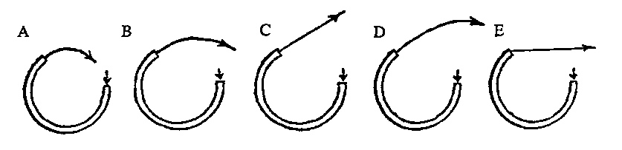

- How much support force does a table exert on a book that weighs 15 N when the book is placed on the table?

- What if a hand pushes down on the book with a force of 20 N?

- What if a rope lifts up on the book with a force of 10 N? (The hand is no longer there.)

- When a 100 N bag of nails hangs motionless from a single vertical strand of rope, how many newtons of tension are exerted in the strand?

- What if the bag is supported by four vertical strands?

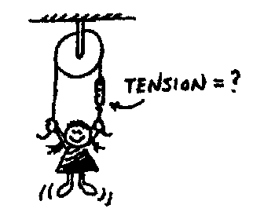

- The little girl in the diagram at the right hangs at rest from the ends of the rope. How does the reading on the scale compare to her weight?

- If the force of friction acting on a sliding crate is 100 N, how much force must be applied to maintain a constant velocity?

- What will be the net force acting on the crate?

- What will be the acceleration?

- How much does an astronaut weigh out in space, far from any planets?

- If suddenly the force of gravity of the sun stopped acting on the planets, in what kind of path would the planets move?

NEWTON’S SECOND LAW

- If the forces exerted on a 2-kg object are 50 N east and 30 N west, what is object’s acceleration?

- Suppose a cart is being pushed by a certain net force. If the net force is doubled, by how much does the acceleration change?

- Suppose a cart is being moved by a certain net force. If a box is dumped into the cart, so its mass is doubled, by how much does the acceleration change?

- If a loaded truck can accelerate at four m/s² and loses its load so it is only half as massive, what acceleration can it attain for the same driving force?

- A rocket fired from its launching pad not only picks up speed, but also has a significant increase in its acceleration as firing continues. Why is this so?

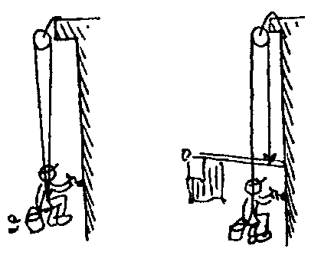
- Harry the painter swings year after year from his boson’s chair. His weight is 500 N and rope unknown to him, has a breaking point of 300 N. Why doesn't the rope break when he is supported as shown in the first figure to the right?

- One day Harry is painting near a flagpole, and for a change, he ties the free end of the rope to the flagpole instead of to his chair. What happens to Harry?

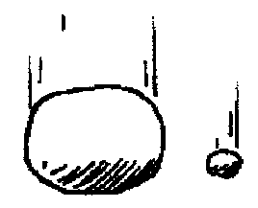
- The force of gravity is twice as great on a 2-kg rock as on a 1-kg rock. Why then does the 2-kg rock not fall with twice the acceleration?

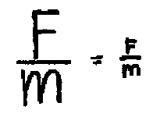
- What is the net force acting on a 10 kg freely falling object?

- What is the net force when it encounters 15 N of air resistance?

- How much air resistance does it experience when it falls at terminal velocity?

- If you pulled a low but heavy crate with a rope and greased the bottom to reduce friction, would it help more to use a short rope or a long rope?

- An elevator (mass = 1000 kg) is supported by a single cable.
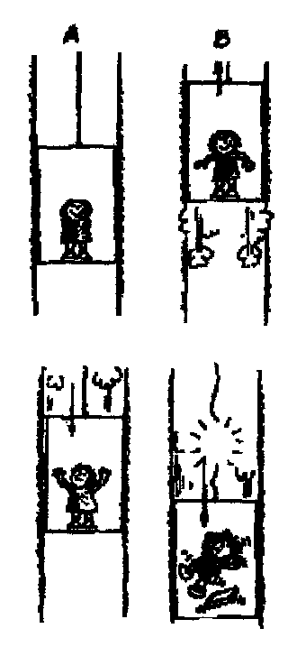
- When the elevator is at rest, what is the tension in the cable?

- The elevator starts to move upwards at 1m/s/s. Is the scale reading more, less, or the same?

- When the elevator is ascending upward at a constant speed, is the tension more, less, or the same as (a)?

- The elevator begins to slow as it reaches the proper floor. Is the tension more, less, or the same as (a)?

- The elevator now starts to descend at an increasing speed. Is the tension more, less, or the same as (a)?

- If the cable snapped and the elevator fell freely, what would be the tension?

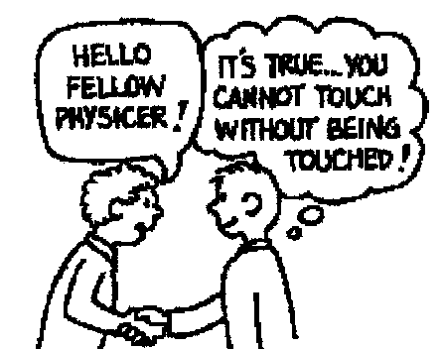
NEWTON’S THIRD LAW

- When a hammer exerts a force on a nail, how does the amount of force compare to that of the nail on the hammer?

- Why does a cannon recoil when it fires a cannonball?

- When you jump up, does the world recoil downward? Explain.

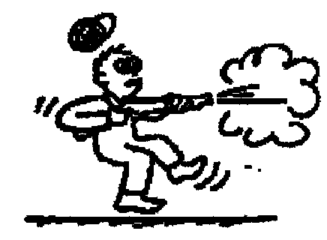
- Why is it easier to walk on a carpeted floor than on a smooth, polished floor?

- When a rifle is fired, how does the size of the force of the rifle on the bullet compare to the force of the bullet on the rifle?

- How do the accelerations of the rifle and bullet compare?

- If a bicycle and a massive truck have a head-on collision, upon which vehicle is the impact force greater?
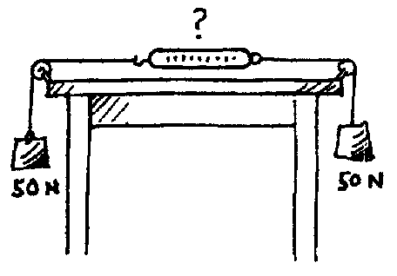
- Which vehicle undergoes the greater change in acceleration?

- A pair of 50 N weights are attached to a spring scale as shown in the diagram. Does the scale read 0, 50, or 100 N?

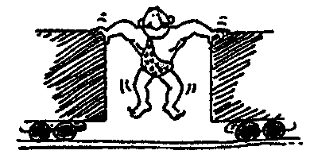
- The strongman will push the two initially stationary freight cars of equal mass apart before he himself drops to the ground. Is it possible for him to set either of the cars in greater motion than the other? Explain.

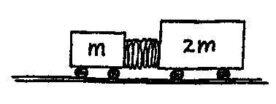
- Suppose two carts, one twice as massive as the other, fly apart when the compressed spring that joins them is released. Afterwards, how do their speeds compare?

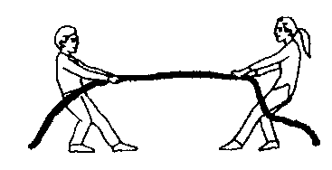
- Two people of equal mass attempt a tug-of-war with a 12-meter rope while standing on frictionless ice. When they pull on the rope, they each slide toward each other. How far does each person slide before they meet?

- Suppose in the preceding example that one person has twice the mass of the other. How far does each person slide before they meet?

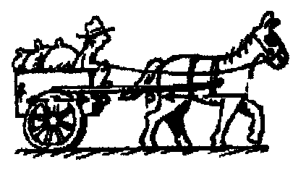

- A horse pulls a wagon with some force, causing it to accelerate. Newton's third law says that the wagon exerts an equal and opposite reaction force on the horse. How can the wagon move?

