Law of Conservation of Energy – Challenge and Friction

- The diagram below shows a 10,000 kg bus traveling on a straight road which rises and falls. The horizontal dimension has been foreshortened. The speed of the bus at point A is 26.82 m/s (60 mph). The engine has been disengaged and the bus is coasting. Friction and air resistance are assumed negligible. The numbers on the left show the altitude above sea level in meters. The letters A-F correspond to points on the road at these altitudes. 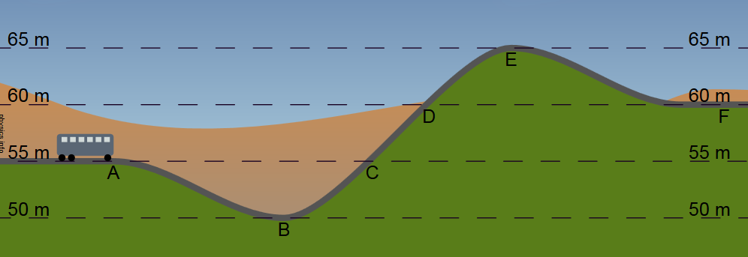
  - Find the speed of the bus at point B.

  - An extortionist has planted a bomb on the bus. If the speed of the bus falls below 22.35 m/s (50 mph) the bomb will explode. Will the speed of the bus fall below this value and explode? If you feel the bus will explode, identify the interval in which this occurs.

  - Derive an equation to determine the speed of the bus at any altitude.

- Four identical balls are thrown from the top of a cliff, each with the same speed. The first is thrown straight up, the second is thrown at 30° above the horizontal, the third at 30° below he horizontal, and the fourth straight down. How do the speeds and kinetic energies of the balls compare as they strike the ground…
  - when air resistance is negligible?

  - when air resistance is significant?
- A 50 kg giant salamander, accidentally steps off a 50 m precipice and falls vertically down. Fortunately, he deploys his ever-ready parachute when he is 30 m from the bottom of the pit full of crocodiles. Ignoring air resistance, what is his velocity the instant before he opens his chute?
  - Solve using Kinematics

  - Solve using Energy

- An 120g paper airplane travels horizontally at 2.3m/s. It dips in its flight, dropping 53cm and is now flying at 3.4m/s horizontally. How much energy was lost to air resistance?

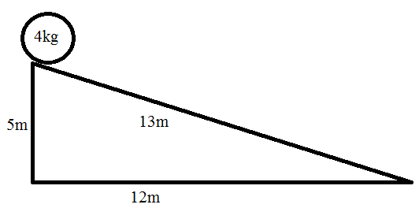
- A ball rolls down a slope. If the ball’s final velocity is 7.3m/s at the bottom of the slope find energy lost to friction.

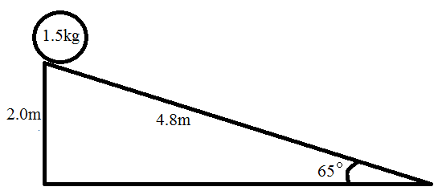
- A different ball rolls down a different slope. The ball experiences 1.2N of friction as it slides down the slope. Find the velocity of the ball when it reaches the bottom of the slope.

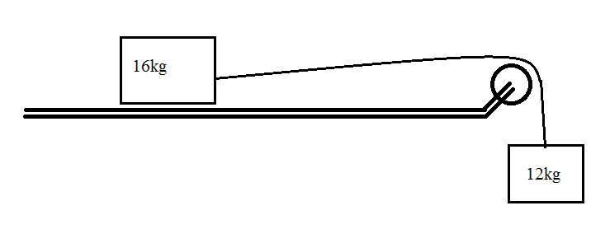
- Two blocks are attached using a frictionless, massless pulley and string as shown in the diagram. If the table has no friction, how fast will the blocks be moving when the hanging block drops 85cm?

- Two blocks are attached using a frictionless, massless pulley and string as shown in the diagram. If the table has a coefficient of friction as shown on the table, how fast will the blocks be moving when the hanging block drops 12cm?

- Two blocks are attached on a slope. Given that the slope is frictionless, how fast will the blocks be moving when the hanging block drops 32cm?
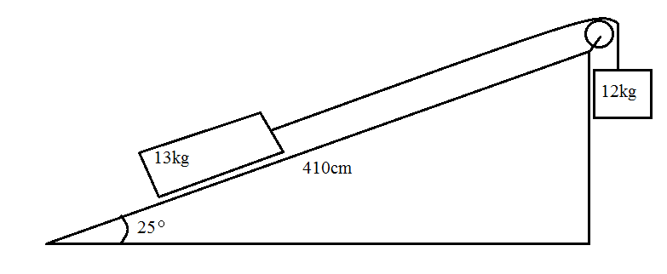

- Two blocks are attached on a slope. Given that the force of friction is 5.4N, how fast will the blocks be moving when the hanging block drops 32cm?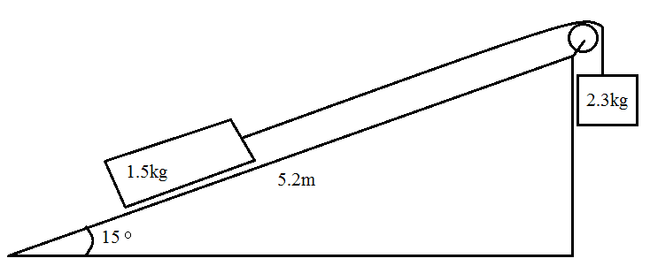
1. a)28.6m/s 3. 19.8m/s 4. 0.25J 5. 89J 6. 5.6m/s 7. 2.7m/s 8. 1.1m/s 9. 1.3m/s 10. 1.5m/s

