Centripetal Force Lab EXAMPLE

Purpose: to explore the relationship between r and T and the force in circular motion.
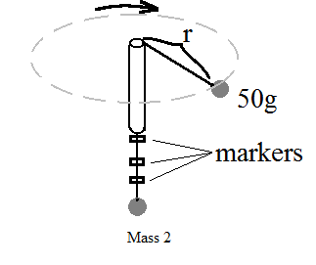
Set Up:
- Thread a 0.5m-0.8m long string through an open tube.

- Attach a 50g mass to one end of the string and an unknown mass (try one that is somewhat larger than the first mass, 200g may be a good size) to the other end. Ensure the masses are secured and will not slip out when moving.

- The lab set up will look similar to the diagram.

Procedure:
- Set up the equipment for the lab as seen in the “Set Up” section.

- Mark five points on the bottom part of the string so they are clearly visible. Measure the radius of the top part of the string when each mark lines up with the bottom of the glass tube. (I recommend radii between 5cm and 20cm)

- Swing the 50g mass in a circle and adjust the speed so the first mark sits at the bottom of the glass tube. Try to keep the top part of the string as horizontal as possible.

- Get used to counting revolutions of the mass. Start a timer and count 20 revolutions. Record your result and calculate the period of one revolution from your result. The data is best obtained with one person swinging and checking the string marker, one person counting revolutions, and one last person timing.
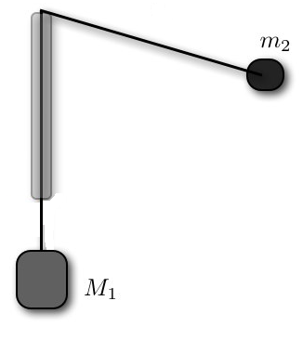
- Repeat the process for the remaining markers.

Data:

Mass 1 | Mass 2

Trial | Radius | Time | Period | Centripetal Force
1
2
3
4
5

Uncertainty:

The centripetal force on Mass 1 should equal the weight of Mass 2. Calculate the percent uncertainty for your tests. Consider the centripetal force the experimental value and the weight of Mass 2 the accepted value.

$$\% error=\frac{Experimental value-Accepted value}{Accepted value}×100$$

