Challenge Questions #2

- Jess is taking the elevator up the CN Tower, it travels at a rate of 3m/s. Jim is a jerk and drops a dog from the top of the CN Tower the moment Jess’ elevator begins to ascend. The CN Tower is 553m. What is the dog’s velocity when it passes Jess in the elevator?

- From the graph, answer the following questions.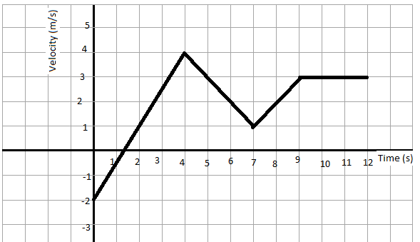
  - What distance did the object travel from 1-4 seconds?

  - What was the objects acceleration between 4-7 seconds?

  - What was the objects acceleration between 3-12 seconds?

