Force Cart Lab – Virtual Lab

Purpose:
To calculate the total amount of friction slowing a system down.

Materials:
- String
- Mass Set
- Wood board
- Pulley
- Cart
- Ticker-tape

Procedure:
- Measure the mass of the cart.

- Attach the pulley to the board and tie a length of string to the force cart.

- Set up the board and materials as seen in the diagram

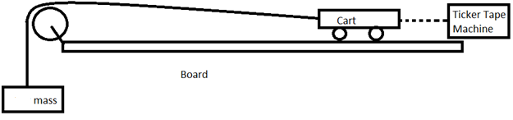

- Attach the tickertape to the back of the cart and start the machine.

- Release the mass hanging from the pulley and let it pull the cart.

Data:

Mass of Cart:

Mass of Hanging Mass:

Ticker Tape Measurement Data Table:
Time | Position | Change in Position | Velocity  (Change in position ÷ Change in time)

Make a velocity vs. time graphs for the set of data.
Results:
- Find the acceleration for the run using the best fit line on your graph.

- Draw and label a FBD of the system.

- Use the net force to find the force of friction for the run of the cart.

Analysis:
- Where are locations in the set up that may provide friction? List them and provide a short description of how each one provides friction.

- Describe at least two sources of uncertainty. Include how they may affect your results numerically. Is there anything that could be done to reduce these changes?

