**Energy Use Estimation Worksheet**

**Purpose**: Using estimates of personal use, this sheet will help estimate your energy use and what it would take to power your use with hydrocarbons or fossil fuels.

**Directions**: Estimate your electrical needs for a daily basis using the chart below. Fill in which appliances you use and estimate the daily usage by filling in the blanks in the table.

kWh is a common form of energy measurement for electricity usage.

1kWh = 3600000J or 1kWh = 3.6MJ

There are 1000 Watt-hours in 1kWh

|  |  |  |  |  |  |  |  |  |  |  |
| --- | --- | --- | --- | --- | --- | --- | --- | --- | --- | --- |
| **Electrical Device** | **Watts** | **×** | **Hours of Daily Use** | | **×** | **Days Used per Week** | **÷** | **7** | **=** | **Avg. Daily Watt-Hours** |
|  |  | **×** |  | | **×** |  | **÷** | **7** | **=** |  |
|  |  | **×** |  | | **×** |  | **÷** | **7** | **=** |  |
|  |  | **×** |  | | **×** |  | **÷** | **7** | **=** |  |
|  |  | **×** |  | | **×** |  | **÷** | **7** | **=** |  |
|  |  | **×** |  | | **×** |  | **÷** | **7** | **=** |  |
|  |  | **×** |  | | **×** |  | **÷** | **7** | **=** |  |
|  |  | **×** |  | | **×** |  | **÷** | **7** | **=** |  |
|  |  | **×** |  | | **×** |  | **÷** | **7** | **=** |  |
|  |  | **×** |  | | **×** |  | **÷** | **7** | **=** |  |
|  |  | **×** |  | | **×** |  | **÷** | **7** | **=** |  |
|  |  | **×** |  | | **×** |  | **÷** | **7** | **=** |  |
|  |  | **×** |  | | **×** |  | **÷** | **7** | **=** |  |
|  |  | **×** |  | | **×** |  | **÷** | **7** | **=** |  |
|  |  | **×** |  | | **×** |  | **÷** | **7** | **=** |  |
|  | | | | **Total Daily Watt-Hours** | | | | | |  |

My daily electricity use in kWh is _______________

My daily electricity use in Joules is ______________

_______MJ in 1 brick of butter (from notes)

Powering my electricity use with butter would take _________bricks/day.



**Driving Energy Use Estimation**

**Driving from Vancouver to Hope**

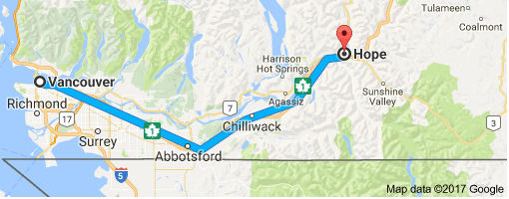

**Distance**: 152.4km by the Trans-Canada Highway

Example Car: 2005 Honda Civic

The Honda Civic takes 5.9L of gas to go 100km on the highway (Source:fueleconomydb.com)

$152.4 km ×5.9\frac{L}{km}= L$ of gasoline to drive from Vancouver to Hope

Gasoline has a density of about 0.73kg/L

$L×0.73\frac{kg}{L}= kg$ of gasoline used

Gasoline has an energy density of 46MJ/kg

$kg ×46\frac{MJ}{kg}= MJ$ of energy used

How much butter would it take to drive a Honda Civic from Vancouver to Hope?

1. Choose a car and research it’s highway fuel economy. Calculate how many MJ of energy it would use and estimate how much butter it would take to power it to drive from Vancouver to Hope.