Displacement/Velocity/Acceleration Graphs

Displacement vs. Time Graphs

This graph describes the motion of an object. (Note: Displacement & Position mean the same thing)
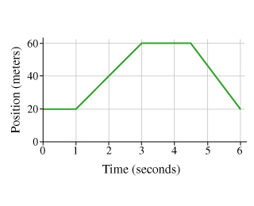

The instantaneous velocity is the slope at a given point. If the point is curved, draw your best guess of a tangent line

The average velocity is the slope from the start, to the end of a time period.

Find instantaneous velocity at 10s.

Find the average velocity over the whole movement.

Using instantaneous velocity, we can construct a velocity graph from any position time graph

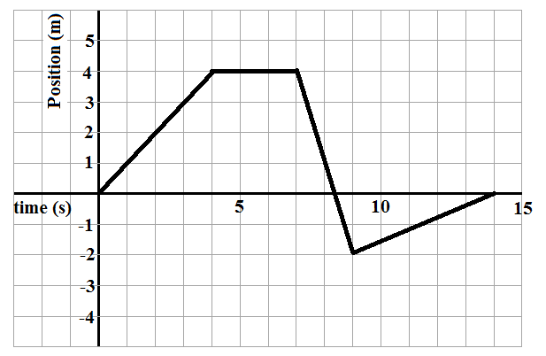
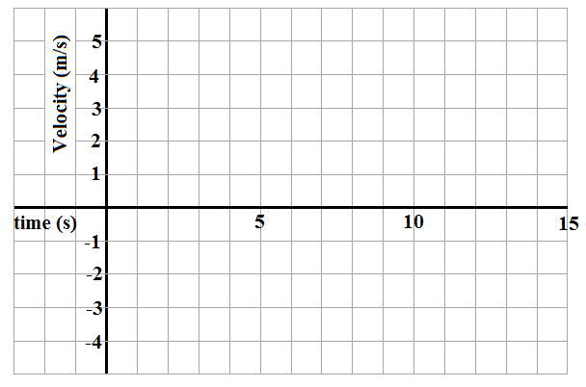

Velocity vs. Time Graphs

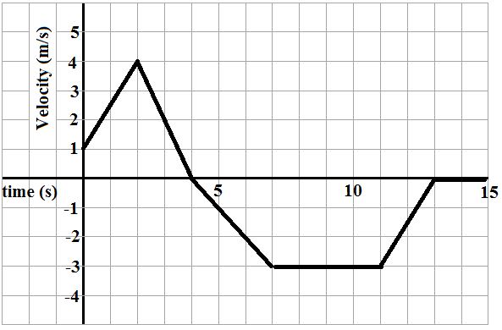
To find the displacement from a Velocity-Time Graph you would find the average velocity then multiply that by the amount of time it travels at that velocity.

Find the displacement travelled during the 2s to 4s time interval.

Acceleration is the rate of change of velocity. It is the slope of a Velocity Time Graph.

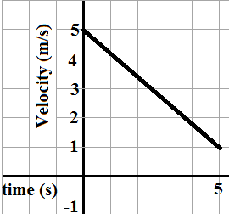
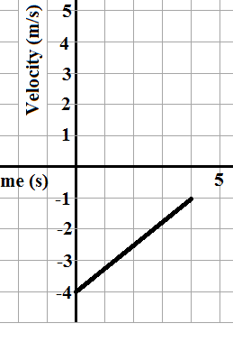
Describe the motion (moving forward/backward) and find the acceleration of the two graphs.

We can also make an acceleration time graph from any velocity time graph.
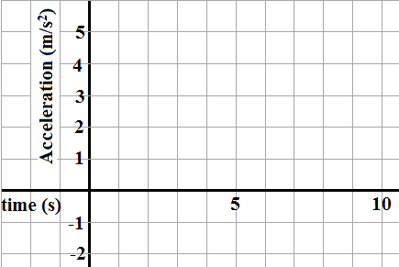
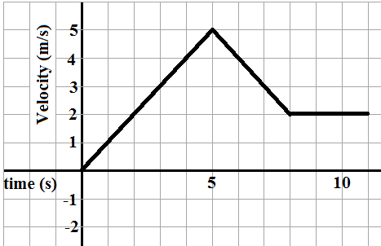

We can look how all the graphs are related
