Name:
Period:

Lab: Modeling Crossing Over

Problem: How does crossing over affect the genes passed down to the daughter cells?

Hypothesis:

Experiment:

Materials:
Pipe cleaners scissors
Procedure:
- Obtain 2 different colored pipe cleaners and cut each in half to represent two chromosomes, each with two chromatids. Twist the pipe cleaners to form two homologous chromosomes, each with two sister chromatids. See below.
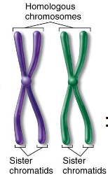

- First, assume that no crossing over takes place. Model the appearance of the four gamete cells that will result at the end of meiosis. Record your model’s appearance by drawing the gametes’ chromosomes and their genes in the data table.

- Next, assume that crossing over occurs between the homologous chromosomes during Prophase 1. Use scissors to cut segments of the pipe cleaners, then attach them to represent the exchange in DNA. See the picture below as an example. Record your model’s appearance by drawing the gametes’ chromosomes and their genes in the data table
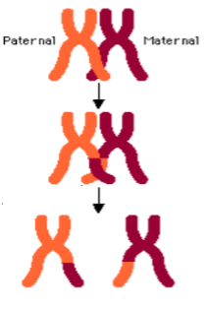

Data:

No Crossing Over | Crossing Over
Appearance of Gamete Cells | Appearance of Gamete Cells

Conclusions:
- Define crossing over and explain when it occurs.

- Compare any differences in the appearance of genes on chromosomes in gamete cells when crossing over occurs and when it does not occur.

- Crossing over has been compared to “shuffling the deck” in cards. Explain what this means.

- What would be accomplished if crossing over occurred between sister chromatids? Explain your answer.

