Convert the following pictorials to schematic circuit diagrams.
.
1. | 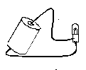 | 3. | 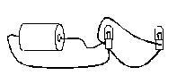
2. | 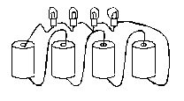 | 4. | 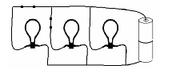

PART 2 - Convert the following pictorials to schematic circuit diagrams.

1. |  | 3.
2. |  | 4.

