Science 9 Current Electricity Review Questions

Complete the table
 | Symbol | Unit
Current
Charge
Voltage
Energy
Resistance

-What is an electric cell?

-What is a battery?

Complete the table
Component | Symbol
Electric Cell

Switch

Light bulb

Resistor

Voltmeter

Ammeter

-How are ammeters set up in a circuit?

-How are voltmeters set up in a circuit?

Current Law I= Q/t

14 C of charge takes 4 seconds to pass by a point in a conductor. What is the electric current in the conductor?
-Electrons flow from the (Positive/Negative) terminal to the (Positive/Negative) terminal.

-Conventional current flows from the (Positive/Negative) terminal to the (Positive/Negative) terminal.

DC is current that:

AC is current that:

Resistors
-Explain how to read the resistance of a resistor using coloured bands.

-What is the resistance of a resistor with orange, black, and red bands?

Ohm's Law: V= IR

What voltage is being used to light up a light bulb that has 0.3A running through it and has a resistance of 25Ω?

What is the current through a 89Ω resistor that is attached to a 1.5V cell?

What is the resistance of a resistor that has 3 V across it and 2 A running through it?

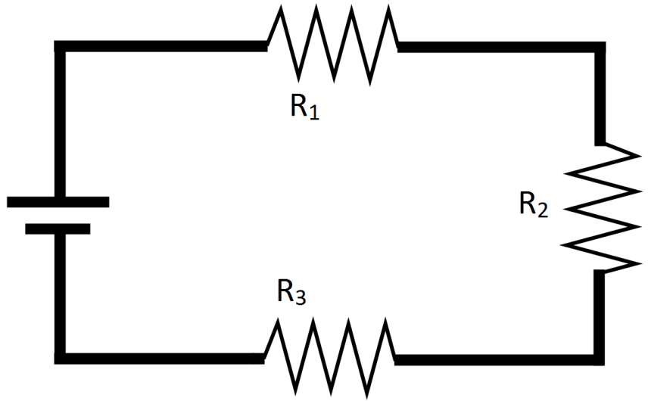
Complete the missing information:

R₁= 20Ω R₂= R₃= 30Ω R_{T}=

I₁= I₂= I₃= I_{T}= 0.2A

V₁= V₂= 8V V₃= V_{T}=

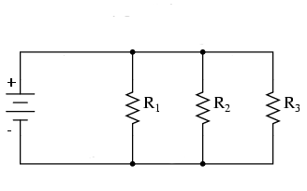

R₁= 1500Ω R₂= 800Ω R₃= R_{T}=

I₁= I₂= I₃= 0.07A I_{T}=

V₁= V₂= 36V V₃= V_{T}=

Three identical resistors are attached in parallel. The first resistor has a resistance of 70 Ω and a current of 0.050 A running through it.
a) Draw a circuit diagram of the circuit.
b) What is the total voltage of the circuit?
c) What is the total resistance of the circuit?

Two resistors, R₁=20 Ω and R₂=60 Ω are connected in series to a source. 0.6 A of current is measured flowing through the second resistor.
a) Draw a circuit diagram of the circuit.
b) How much current is flowing through the first resistor?
c) What is the voltage across the first resistor?
d) What is the total voltage in the circuit?
e) What is the total resistance in the circuit?

