Candy DNA and RNA Transcription Activity

Purpose: To show the basic structure of DNA and the process of RNA Transcription
- Assign a colour of gummy bear to each nitrogen base:
Adenine= ______________________ Thymine= ______________________
Uracil= ______________________
Cytosine= ______________________ Guanine= ______________________
- What do the red Twizzler’s represent? ______________________________________
- What do the black Twizzler’s represent? ______________________________________

DNA Construction
- Choose six nitrogen bases to be on your LEADING STRAND of your DNA.
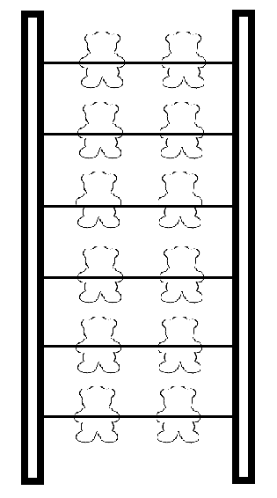
- Match the bases that will be in your LAGGING STRAND.

____________ ______________

____________ ______________

____________ ______________

____________ ______________

____________ ______________

____________ ______________

Completion Check:
- Build your DNA using the candy
Translation
- “Unzip” your DNA into the two strands.
- Make the RNA copy of the DNA by building a your RNA to match and fit onto the Leading Strand of DNA.
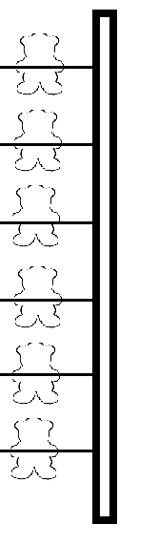
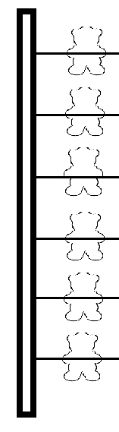
LEADING STRAND of DNA MATCHING RNA

________ ___________

________ ___________

________ ___________

________ ___________

________ ___________

________ ___________

Completion Check:

Follow Up Questions
- What is the function of DNA?

For each of the following sequences, fill in either the DNA or the mRNA sequence that has been left blank.

- DNA ___
mRNA A U G A C U A G C U G G G G G U A U U A C U

2. DNA T A C C G C T C C G C C G T C G A C A A T A C C
mRNA _

- What are two differences between RNA and DNA?

- Where is DNA found in the cell?

- Where does RNA travel in the cell?

- What are the steps of transcription?

