Adaptations of Fish for Eating

What do fish eat?

Fish Body Shapes

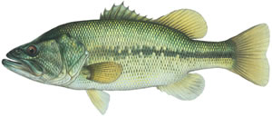
Rover Predator

Have elongated body with fins distributed evenly about the body. Its body allows it to “rove” through different types of habitats including _______________________________________. Uses speed to catch prey.

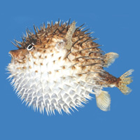

Round Body

The round body makes these fish slow swimmers, but very hard to _____________________.

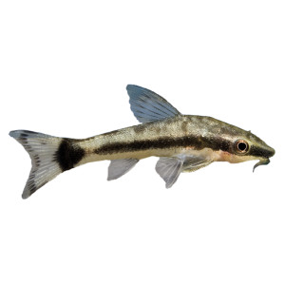

Flat Bottomed Fish

Have a flat bottom allowing it stay close to the bottom and feed off things off the bottom like shellfish, plants, or dead animals. Many fish may _____________ underneath the soil.

Torpedo Bodies

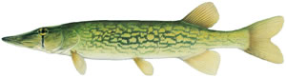
Have elongated/torpedo shaped bodies with fins near the back of the body. Its shape provides thrust for _____________________ to surprise and catch its prey. Lies hidden in still or slow moving water and darts out to snap up its prey.

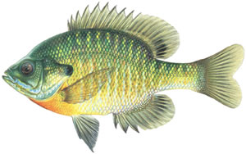
Flat-Bodied from Side-to-Side

Have flattened bodies from side to side. Mainly occurs in still water and adapted for maneuverability in heavy cover. Hard to see from the __________________.

Eel-like Fish

Have very elongated bodies and are adept at swimming through tight places and burrowing in ___________________. Typically sneak up on prey by hiding in rocks and weeds.

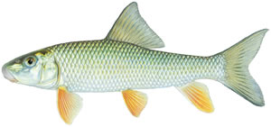
Humped Backed Fish

Have similar shaped bodies to rover-type bodies but has a humped back to help it stabilize in ____________________ water.

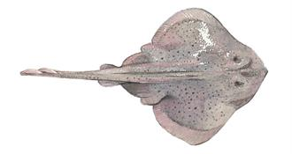
Flat-Bodied from Top-to-Bottom

Have a very flat body allows it to stay close to the ground and ______________________ with the bottom of the floor.

Fish Mouth Types
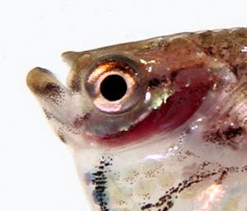
Superior Mouth

The superior mouth is oriented upwards, with the lower jaw being longer than the upper jaw. Usually, fish with this type of mouth feed at the ______________________. They lay in wait for prey to appear above them, then strike suddenly from below. Many species eat insects

Terminal Mouth
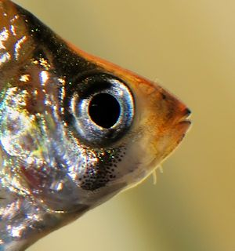
Terminal mouths are located in the middle of the head, pointed straight forward, with both jaws being the same length. More fish have this mouth type than any other. Fish having a terminal mouth are generally __________________________________, however they can feed at any location. These species of fish are often omnivores, eating anything that is available. They typically feed on the move, either grabbing bits of food that they pass close to, or prey on other fish that they chase down.

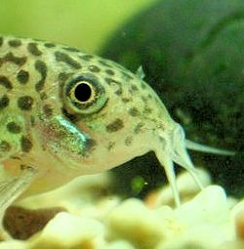
Inferior Mouth

Also called a sub-terminal or ventral mouth, the inferior mouth is turned downward. The lower jaw is shorter than the upper jaw, and the jaw will often be protrusile. Fish with inferior mouths are _____________________ that often possess barbels (_______________________) that assist in locating food particles.

Sucker Mouth
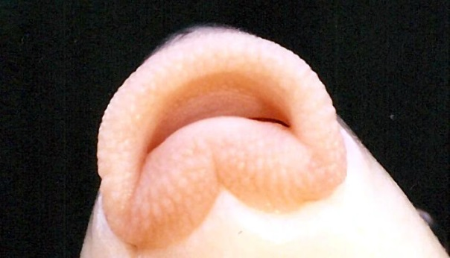
Sucker mouths are a common feature in fish with inferior mouths. Catfish such as the popular pleco, use their sucker mouth to rasp __________________ off driftwood or rocks. Some species may also use the sucker to help them combat currents. By attaching themselves to a rock via their sucker mouth, they are able to stay where they wish, even in a strong current.

Elongated Mouth
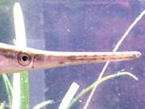
Another type of mouth adaptation is a greatly elongated snout. This type of mouth allows the fish to poke into _____________________________ to find food. They may also use such a mouth to dig through the substrate to reach buried food treasures. Some surface feeding fish also have an elongated mouth that allows them to scoop insects and food particles from the surface.

Beak Mouth
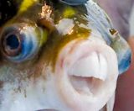
An interesting, but less common, mouth variation is the beak mouth, also known as a rostrum. In this cases the mouth consists of two very hard pieces that are hinged and come together in a scissor-like fashion. This allows them to crush ____________________________________________.

Table of Adaptations and Their Purposes

Body Part | Adaptation | Purpose
Mouth | at the end of the snout, symmetrical
 | angled downward/longer upper jaw
 | angled upward/longer lower jaw
 | strong jaws - teeth
 | sucker-shaped
 | no teeth
 | very large mouth
Eyes | both on the same side of the head
 | small
 | large
Body shape | round
 | flat bottomed
 | long, eel-like
 | torpedo shaped
 | flat from side to side
 | flat from top to bottom
 | hump backed

