Acceleration and Velocity-Time Graphs

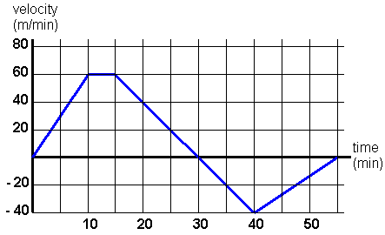
Describe the motion from the velocity time graph.
Velocity Acceleration
From 1s-10s

From 10s-15s

From 15s-30s

From 30s-40s

From 40s-60s

Since acceleration is the ___________________ of velocity. The average acceleration of an object can be found from the __________ of the velocity-time graph.

