Isotopes

Atomic Theory Review:

All atoms are made of three particles:

Most all of the mass in any atom is due to its _____________ and _____________. The atomic number of an element represents the number of _____________ in one atom of that element. The mass number is the number of both ______________ and _______________ in the element. This gives us some handy formulas:

Representing Elements:

In nuclear sciences there is a given way to represent any given set of atoms. It involves using the chemical formula, mass number and atomic
number.

Example:
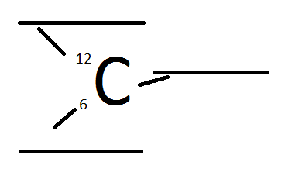
Another way to say this is __________________. The type of element will tell us how many protons are in the nucleus and using the mass number, we can find out how many neutrons are in the nucleus as well.

Isotopes

Not all elements on the periodic table have simple integer mass numbers. We can't have only part of a proton or part of a neutron, so what causes this? A particular element may have differing numbers of neutrons. This is called an ________________. An _______________ is a particular element with a specific mass number. For example __________________ and ___________________ are two isotopes of carbon. Carbon-12 has ___ protons and ___ neutrons. Carbon-14 has ___ protons and ___neutrons.
Chemical Formula | Isotope Name | Number of Protons | Number of Neutrons | Atomic Number | Atomic Mass
$${}_{17}^{35}{Cl}$$ | chlorine-35
 | sulphur-34
 |  | 27 | 32 |  | 59
 |  |  |  | 92 | 238

Isotopes and Atomic Mass

The atomic mass of a chemical is given by the average value of the mass of all of an element. For example if you analyzed a lump of pure carbon you would find out that it has three main isotopes. 98.89% of all carbon is carbon-12, 1.10% is carbon-13, and 0.01% is carbon-14.

Use the percent of the isotope times its mass and add it all up:

Example:
Iron has three stable isotopes. Iron-54 has a 5.80% abundance, iron-56 has a 91.72% abundance, and iron-57 has a 2.20% abundance. What is the average atomic mass of iron?

