Chapter 5.1 Acids and Bases

Many familiar compounds are acids or bases. They have many uses and many are essential for life.

Acids and bases can both be very corrosive, never identify an acid or base by _______________.

**pH Scale**

The strength of acids and bases are measured on the pH scale.

0 1 2 3 4 5 6 7 8 9 10 11 12 13 14

Some pH’s of common items



Each **decrease** of pH by 1 is a _______ more ______________.

Alternatively each **increase** by 1 is ________ more _____________.

**Indicators**

pH normally can’t be determined by sight. Instead we use chemicals called **indicators** to tell us the approximate pH of a solution.

Indicators change _______________ based on the pH of the solution they are placed in.

The most common indicator is ______________________________.

There are two colours to litmus paper:



Here is a table with some more indicators and the ranges where they change colour:

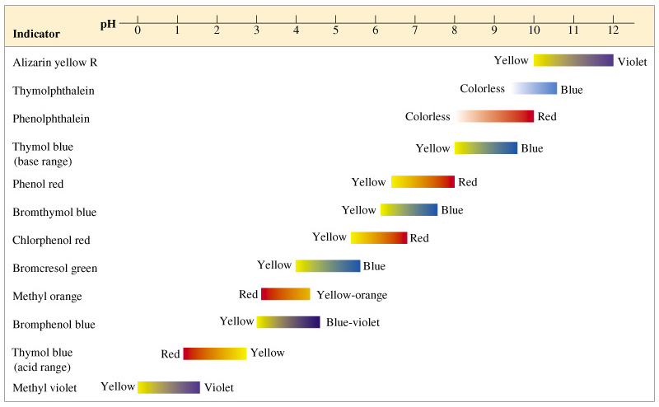

Acids and bases often only behave like acids or bases when dissolved in water. You will regularly see a (aq)=aqueous on acids or bases, meaning they are dissolved in water.

**Acids**

Almost always start with __________________.

**Naming acids:**

Naming acids follows three rules

🡪

HCl

HF

🡪

H2SO4

H2CO3

🡪

H3PO3

HNO2

**Bases**

Almost always end with ____________

Some examples of bases:

**Properties of Acids and Bases**

|  |  |  |
| --- | --- | --- |
| **Property** | **Acid** | **Base** |
| **Taste** |  |  |
| **Touch** |  |  |
| **Indicator Test** |  |  |
| **Reaction with Metals (like magnesium or zinc)** |  |  |
| **Electrical Conductivity** |  |  |
| **pH** |  |  |
| **Production of Ions** |  |  |

Homework p. 233 Check Your Understanding