The Electromagnetic Spectrum (EM spectrum)

All of us are surrounded by invisible waves travelling around and through us. All wireless communication and many of our technological devices use ________________ ____________, which is also known as __________________ ________________. The type of EM radiation we are most familiar with is _____________ _________.

All EM radiation is the movement of _________ particles called _________. Different types of ____ _________ _____________ are light moving with different ________________________ and _______________________.

A Chart of the EM Spectrum
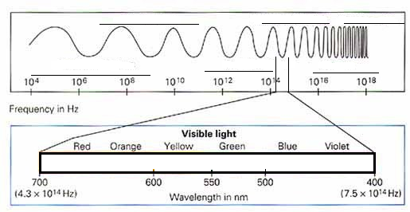

Radio waves
- These waves have the longest _________________, and lowest _________ and __________________ compared to the other waves.
- They are often used for broadcasting _____ or ___________.
- In the medical field a magnetic resonance imaging (_____) machine will magnetically line up small particles in bone and tissue then suddenly change the orientation of those particles. When the particles move they release energy in the form of __________ ________, which are read by the MRI machine to make a map of the tissues.

Microwaves
- These waves are slightly __________ than radio waves and have more __________.
- The energy from microwave radiation is very easily absorbed by ________.
- A microwave in your house will send microwaves at food and the __________ in the food will absorb the energy and heat up. Microwaves don’t work well on food without any _________ in it.
- Microwaves are also used as ____________. The waves are sent out, will bounce off an object, and be received from the same place they were sent. The time it takes for the radar to go out and come back is used to determine how away the object is.

Infrared waves
- Infrared is the most common wave used in ________________ technologies like remotes and reading CD’s or Blue Ray Discs.
- ________ _____________ also uses infrared waves, as warm object will emit more infrared than cold objects.

Visible Light
- This very short section of light waves are the only ones we can see with our eyes. Our eyes formed to specifically only recognize the light waves that travel through water the best. NEAT!

Ultraviolet
- Ultraviolet waves have a slightly ____________ wavelength and have more ___________ than visible light.
- Ultraviolet radiation enables your body to process ____________ ___, but over exposure can result in _____________, ________ ___________, and ______ ______________.

X Rays
- X rays have a much shorter wavelength and higher energy than visible light.
- X rays can pass through _______ _________ easily but will bounce off _________.
- This allows doctors to take pictures of your ________ and __________ without having to cut you open.
- Since the X rays have _____ _________, too much of them can be harmful.

Gamma Rays
- Gamma rays are the ___________ energy, ____________ wavelength type of EM waves.
- These high energy waves mostly come from the ____________ ______________ ______________ happening in _________.
- We have recently been able to used highly _____________ beams of gamma rays to kill sections of ____________ _____________ in the body.

Homework p.163 #1,2,7,8,9,10,11,12

