Incomplete Dominance & Monogenetic Traits

More Vocabulary

Homozygous:

Heterozygous:

Incomplete Dominance

When members of a pure line of ________ carnations are crossed with pure ____ carnations the resulting hybrid offspring are _______.

In this case, neither the _______ nor _______________ alleles are completely ___________________, so the heterozygous children will have a phenotype that is in between the two homozygous parents.

The heterozygous carnations are a bright pink, rather than a faded pink, which implies the red allele is slightly more ___________________ than the white allele.

Red allele:
White allele:
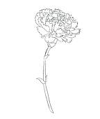
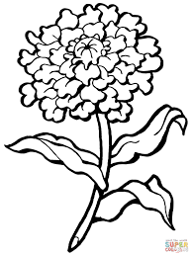
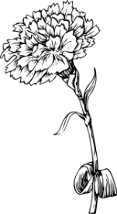

Monogenetic Traits

Monogenetic Traits:

Examples of monogenetic traits in humans:
- Free or Attached earlobes

- Presence or absence of Widow’s peak

- Tongue rolling ability or inability

- Presence or absence of eye pigment

- Presence of absence of Hitchhiker’s thumb

Monohybrid cross:

Dihybrid cross:

For example we could look at the making between Jim and Pam. Jim has a widow’s peak and is able to roll his tongue (WWRr). Pam has a widow’s peak, but cannot roll her tongue (Wwrr)

To predict the possible offspring of a dihybrid cross we need a _________ Punnet square.

