Science 9 Name:__________________
Ch 1.1a notes Blk: ____ Date: _________

Ch 1.1a: Introduction to Biomes

A) Introduction to Biomes
- Biomes are the largest divisions of the biosphere.
- The large regions within biomes have similar _____________ and _____________ components.
- The interaction of these components determines the characteristics of biomes.
- _________________________ and _____________________ are the main abiotic factors that influence the distribution of biomes and the organisms within them.
- Organisms have adaptations for survival in the specific environmental conditions of their biome.

B) What Is a Biome?
1. Biosphere
- The thin layer of air, land, and water at Earth’s surface where living things exist.
- Can be further divided into _____________, _______________
and ____________________.(see Figure 1.3, BC Science p.9)

2. Biome
- A large area of the biosphere that has characteristic __________, _____________, ___________ and ___________.
- Can be ___________ (water-based) or ___________ (land-based).
- Biomes are classified based on many qualities, such as ____________________, ________________, and __________________________________________________.

3. Every environment has living (biotic) and non-living (abiotic) components.
- Biotic factors: are all organisms in the environment
  - E.g. _____________________________________________
- Abiotic factors: are all non-living parts of the environment
  - E.g. _____________________________________________
- Biotic and abiotic factors interact and determine what characteristics a biome will have.

Practice Problem:
1. List the biotic and abiotic factors of the following pond water ecosystem.
2. Discuss in what ways the biotic and abiotic factors may interact.

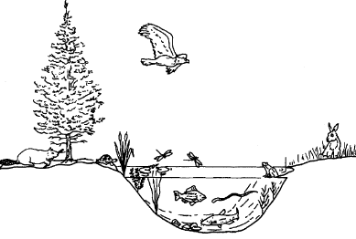

Factors | Biotic | Abiotic
At least 3 Examples | 1.  2.  3. | 1.  2.  3.
At least 3 Interactions | 1._____________________________________________________________  2. ____________________________________________________________  3. ____________________________________________________________

C) Biomes of the World
1. There are 8 Main Biomes:

  - boreal forest
  - desert
  - grassland
  - permanent ice
  - temperate deciduous forest
  - temperate rainforest
  - tropical rainforest
  - tundra
- Similar biomes can exist far apart.
- The distribution of biomes is related to:
- the amount of annual rainfall, temperature, latitude, and geographic locations (along coast, mountains, etc.)

Activity 1: Observing Patterns in World Biomes
Study the map and observe the patterns you see in the distribution of biomes. Record them below.
Biomes | Usually Found…
- Tropical rainforests
- Boreal forest
- Deciduous forests
- Tundra
- Grassland
- Temperate rainforests
- Deserts
- Permanent ice

Practice Problems
1. Identify each of the following as either a biotic or an abiotic factor.

(a) crab ___________________
(b) ocean temperature ___________
(c) lake water ___________________
(d) dissolved oxygen ____________
(e) tides ___________________
(f ) seaweed ___________________

2. Refer to the identified patterns from the Activity 1. Provide an explanation for any two of these observed patterns based on your general knowledge.

________________________________________________________________________________________________________________________________________________________________________________________________________________________________________________________________________________________________________________________________

