Natural Selection Student Notes – Oct 2017 - Day

Natural Selection
Definition – the _______________ by which individuals are better suited (or ________________) to their environment ____________ and ________________ most successfully. This is also called survival of the fittest.

Natural selection is key to our understanding of evolution.

But first, a bit of history

Early Concepts of Evolution Buffon:
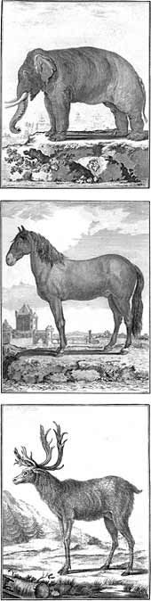
Buffon (1707 – 1788)
- to understand the world, he needed to understand ___________

- Estimated the world was _____________ years old

- He thought life can be divided into a number of distinct types based on the type of “particles” that are available. When they migrate, there will be new particles available in a new area, so they can make a new form of animal.

- For example – the 3 animals pictured on the left >>>

Lamarck (1744 – 1829)
- first scientist to recognize living things _____________ over time

- HOW it happened was ________

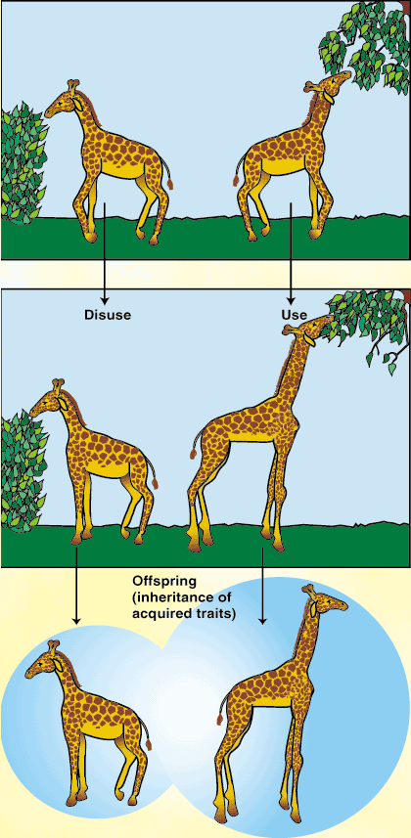
-Lamarck’s theory relied on 3 incorrect assumptions:
- An organism has a ____________ ___ _________
  - Organisms have an inborn desire to better themselves and become more fit for their environments.
- Be engaging in certain behaviour. Use or _________
  - Organisms can alter their shape by using their bodies in new ways.
- These _______________ traits can be passed on to the next generations
  - Acquired characteristics are inherited.

Example –
Giraffe on the right - uses his neck to reach higher and higher trees. Because of this, future generation have longer necks.

Giraffe on the left - only eats short trees, he doesn’t use his neck (disuse). So, next generation has a short neck.

Charles Darwin (1809 – 1882) –
Spent five years sailing around the world, collecting specimens and making many observations.

Where did the HMS Beagle go?
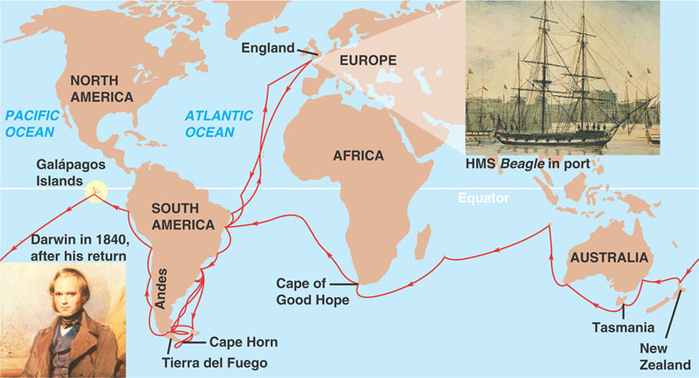

Looking at his observations and information from other scientists, he make four (4) key observations:
- The earth was very ________ – millions not thousands of years old (Lyell and Hutton)

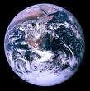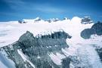

- Humans produced __________ ______________than could survive. Disease, war and famine helped to control the population size.

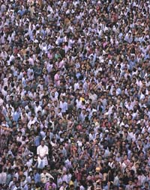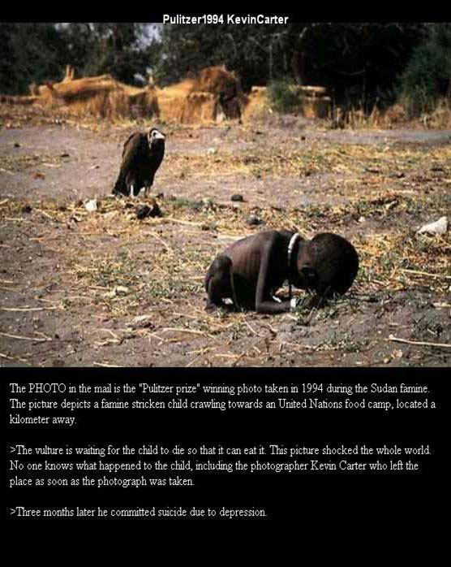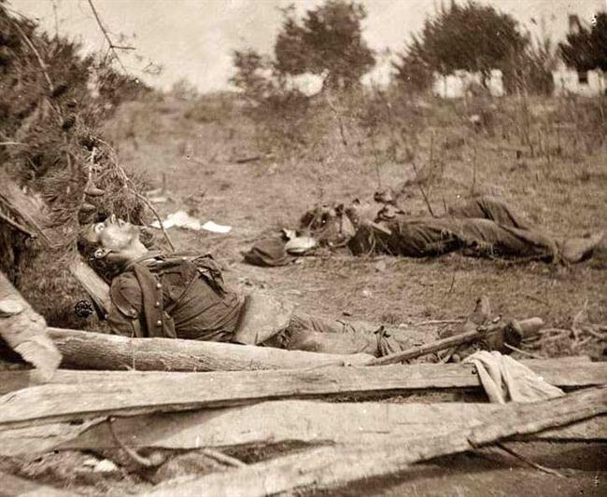
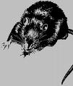

- There is ____________ in nature. (e.g. starfish, leaves, grade 10 students, dogs, cats).

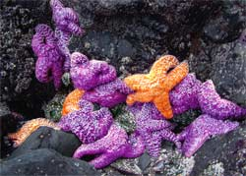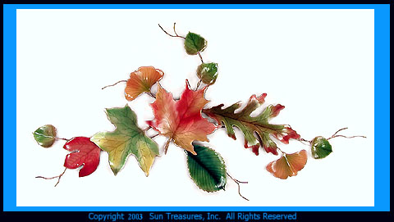

Farmers would look at their plants and livestock and breed or select the traits they are looking for. This is called ______________ selection.

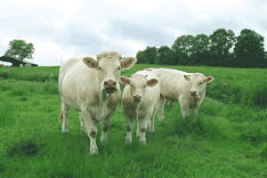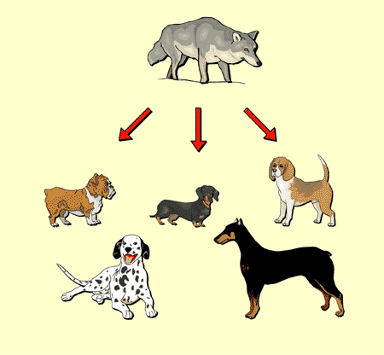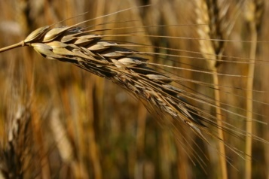
- The ____________________ (biome, ecosystem, habitat) animals live AND the animals adaptations impact whether they will survive to reproduce or not.

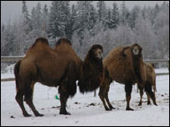
Example: Camels in Norway have not problems surviving the cold. Why?

-thick wooley coat

These observations led to Darwin’s theory of evolution. Darwin stated:
- All organisms are descended from _____________species that are different from __________ species.

- _______________ selection provided a mechanism for this evolutionary change.

Darwin’s idea about evolution by natural selection has 5 key parts. It is simple, but often misunderstood.

- There is variation in traits among members of the ____________ species
  - Look around the room, every grade 10 student is different. We are all humans.
  - Look at dogs – all dogs are dogs – but there is a lot of variety in height, weight, colour, fur/hair, etc.
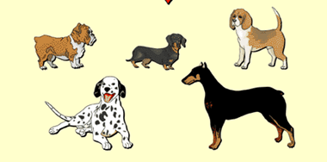

- Organisms produce _________ ______________than can survive. Darwin called this overproduction. And, of the organisms that survive, not all get to ___________.
  - Since the environment can’t support unlimited population growth, not all individuals get to reproduce.

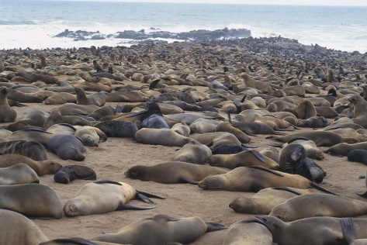

- Because more organisms are produced than can survive, they ____________ for limited resources. E.g. food, water, living space

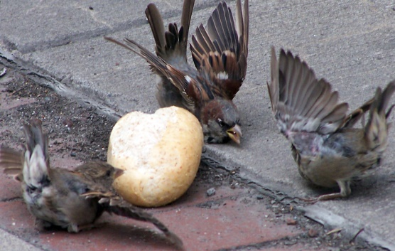

- Each organism has different advantages and disadvantages in the struggle for existence. Individuals best suited for their environment _______________ and ____________.

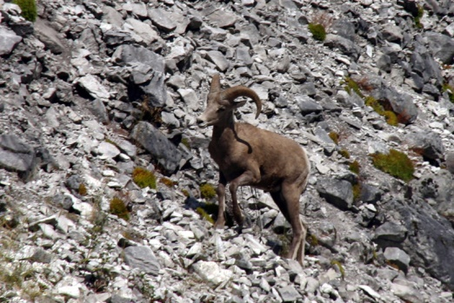

- So, it’s those characteristics and traits that get passed on to the next generation. i.e. heredity. Over numerous generations, new species arise by the accumulation of variations inherited from their ancestors
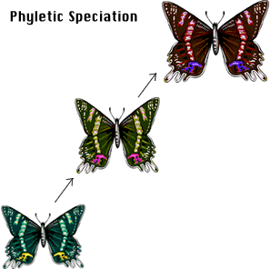
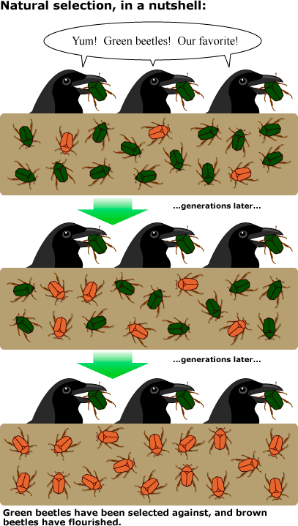
Consider an example:
- There is variation in __________
  - For example, there may be some beetles that are green and some that are brown

- There is a struggle to___________.
  - Since the environment can’t support unlimited population growth, not all individuals will survive and reproduce AND.
  - Beetles are a source of food to birds. Birds eat the beetles.
- There is _______________
  - The surviving beetles have baby beetles. Brown beetles will have brown beetle babies and green beetles will have green beetle babies.

- There is the _______________ the beetles live in.
  - If the beetle lives mostly on brown soil – which beetles get eaten more often by the birds? The green beetles. As the green beetles are eaten more than the brown beetles there will be more brown beetle survivors.
  - The end result? The brown beetle becomes more common than the green beetle. With more generations of beetles being eaten and reproducing there will eventually be no more green beetles.

