Why and How to Talk About Energy?

Some people are concerned about CO₂ emissions, but what does that have to do with energy?

The following chart is a breakdown of the greenhouse gas emissions of the world by source and type of gas:

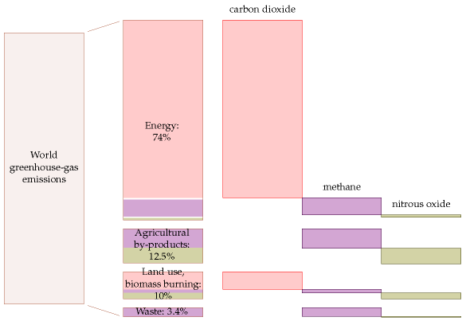
Source: Sustainable Energy Without The Hot Air, David MacKay, from the Emission Database for Global Atmospheric Research, 2000

Greenhouse gas emissions are changing our global climate. As we see above, ____________ ___________________ is a _________________ part of this change. The goal of this lesson is to figure out a useful way to talk about how we produce and consume energy so we can ______________ claims made by others and make our own claims that have a solid foundation in _____________.

How we need to talk about Energy:

_______________________, not _____________________

When people do not have an understanding of the numbers, newspapers, campaigners, companies, and politicians can say almost anything they want.
We need simple numbers that are understandable, comparable and memorable.
With proper numbers, we can begin properly trying to answer questions like these:

- Can a country like Canada live on its own renewable energy sources?
- If everyone turns puts in a little effort, or makes some changes, will it make a noticeable difference?
- What could or should be done to encourage people do what is right?
- Is misinformation dangerous? If there’s information or misinformation that people are spreading, who could it hurt? How would it damage people’s lives?
- If climate change is “a greater threat than world wars,” should governments criminalize actions that further climate change?
- Will a switch to “advanced technologies” allow us to eliminate car-
bon dioxide pollution without changing our lifestyle?
- Is the population of the Earth too big?

Types of Assertions you will Encounter:

Assertion: An assertion is a declaration that's made emphatically, especially as part of an argument or as if it's to be understood as a statement of fact.
Source: https://www.vocabulary.com/dictionary/assertion

Factual Assertions are:
- _____________ – Meaning they are based on an actuality, real, true things that can be proven, repeated or observed
- ____________ – A factual assertion doesn’t care who is right. It just is
  - Examples of Factual Assertions:

    - Guardians of the Galaxy Vol.2 made around _____________ more on opening weekend then the original Guardians of the Galaxy in domestic markets

- Factual Assertions are NOT opinions

Ethical Assertions or Commonplace Assertions are:
- ________________ – Meaning these assertions are based on the values on the person who is making the argument. Others may not hold the same values.
- _______________ – An ethical assertion is about what is right and wrong it will favor a particular set of values
  - Examples of Non-Factual Assertions:

    - Guardians of the Galaxy Vol. 2 was funnier and overall a better movie than the original Guardians of the Galaxy

In this class, we will try to stick to FACTUAL assertions and arguments. ETHICAL and COMMONPLACE assertions and arguments are your own to form.

To help us understand these numbers we need to make them accessible or understand them by relating the numbers to something we know: ____________!
Butter is a combination of carbon atoms with hydrogens attached (called a _____________________). Fossil Fuels are ________________________… so maybe we can use one to relate to the other?

Let’s take a look at the Nutrition Label on butter.
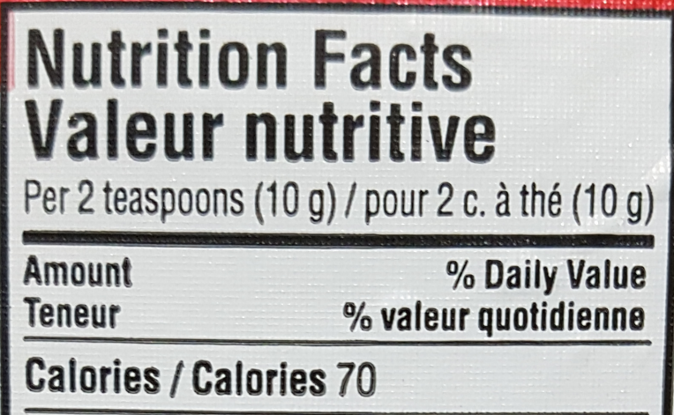
- There are _______ calories in _____ g of butter.

- The conversion from food calories to joules is 1 food calorie = 4184 J

- So there are ______ joules in _____ g of butter, or ________ joules per kilogram

- One block of butter is 454 g, so there are _____ J in one block of butter

How close is this to actual fossil fuels?

Energy Density of Some Hydrocarbons:
- Butter: __________
- Coal: ___________
- Gasoline: ________
- Natural Gas: _______
Source: http://energyeducation.ca/encyclopedia/Energy_density

How is Canada Doing in Terms of Energy Production?
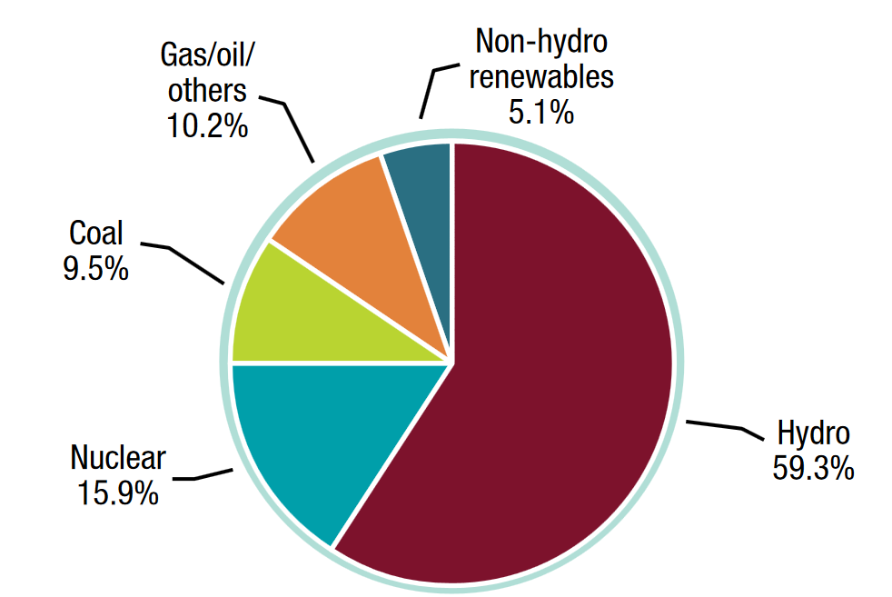
Source: Energy Factbook 2016-2017, pg.95, https://www.nrcan.gc.ca/sites/www.nrcan.gc.ca/files/energy/pdf/EnergyFactBook_2016_17_En.pdf

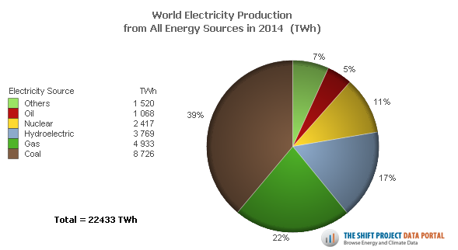
Note: Canada has an abundance of hills and water. This makes it particularly well situated to take advantage of hydroelectric power. Canada is #1 in the G7 in terms of using non-fossil fuel energy production methods. The majority of world energy production is done with fossil fuels like coal or natural gas.

