Equilibrium – 1 – Translational Equilibrium
Example 2: A 5.0kg box is lifted from the floor at a constant velocity of 3m/s. Draw a free body diagram and determine the values of the forces acting on the box.
Example 1: A 5.0kg box is sitting on the floor. Draw a free body diagram and determine the values of the forces acting on the box.

In both above examples:
The motion is
The forces are

When this is the case, it is said the object is at _____________________________________.
When an object is at rest it is at ___________________ __________________________________
When an object is moving at a constant velocity it is at ________________ _______________________

In both of the examples, the object was in ______________________________________________ equilibrium

Translation refers to moving in a _________________ (ie. )

Therefore, the conditions for _____________________________ ______________________________ are:
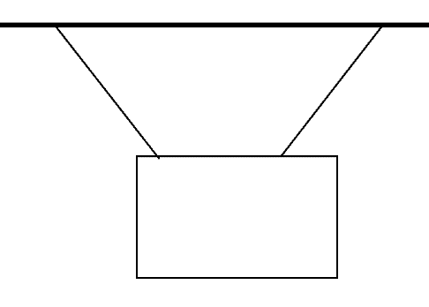
F_{NET} =
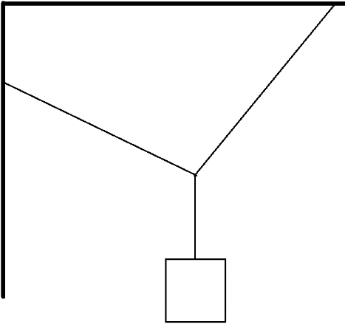
OR

F_{NET X} =

F_{NET Y} =
How to solve with components
- Identify. Is this situation in equilibrium?
- Draw a FBD, look for where the forces intersect.
- Break the forces into components.
- Use F_{NET} to solve for your unknowns.
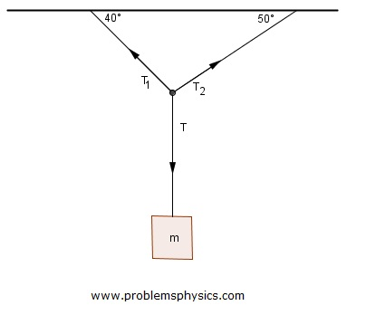
T₁=50N. Determine the mass of the block.

How to solve with trig
- Identify. Is this situation in equilibrium?
- Draw a FBD
- Turn your vectors into a triangle. Situations in equilibrium should have zero net force, thus should always end where they started.
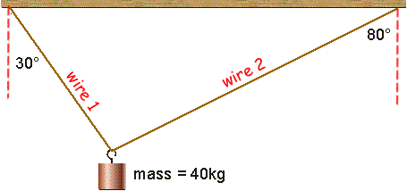
- Use Sine and Cosine Laws to solve for your unknowns.
Determine the tensions in the two wires.

Example: Determine the tension in rope B when the angle θ=25°.
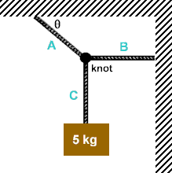

Example: What is the mass of the traffic light if string AB has 150N of tension?
