Traits – Inherited vs. Acquired

Traits or Characteristics are:

Examples:

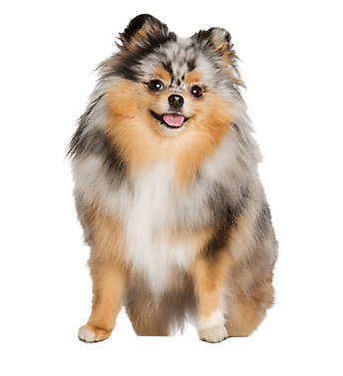
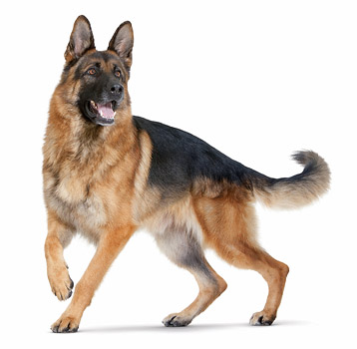

Traits can be ______________________________:

- They describe the way something ___________________

- They describe the internal ______________________

Examples:

Traits can also be _______________________________:
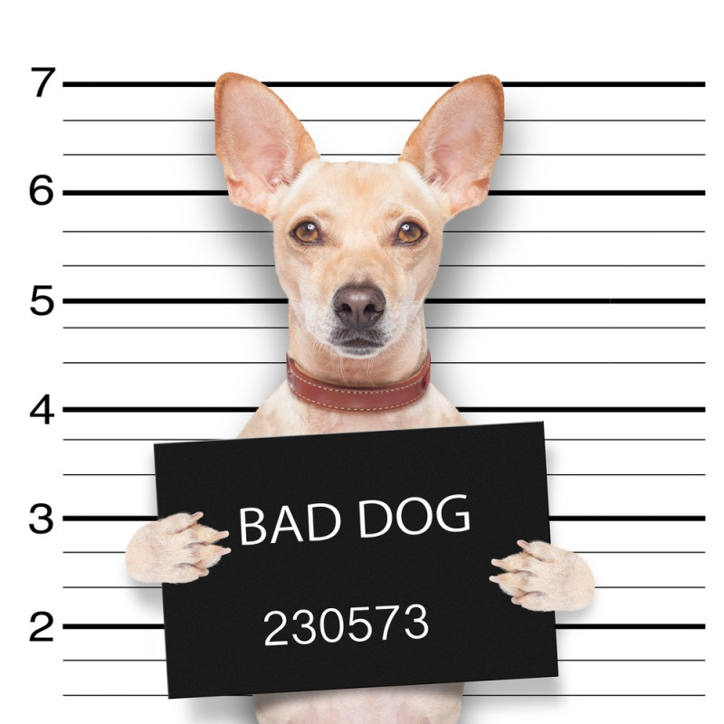
- They describe the way something _______________

- They describe something that was ____________________

Examples:

Traits can be ___________________ or _____________________
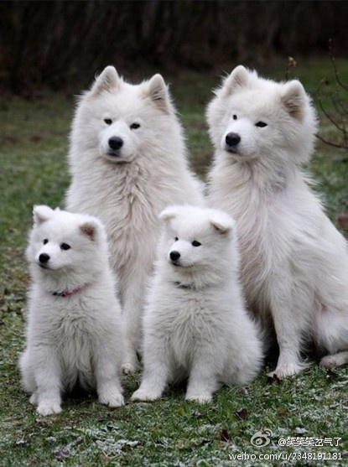
Genetic or Inherited Traits
- Inherited traits are coded in your ________

- Received from your biological ________________

- Inherited behaviours are often called ___________________________

- Because they are coded in your ______ they can be ________________ ______ to the next generation

Examples:

Acquired Traits
- _________________ during your life (you are not born with it)

- Not in your DNA

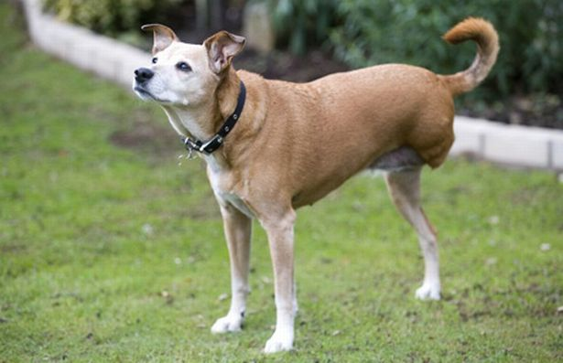
- Cannot be ________________ __________ to the next generation

Examples:

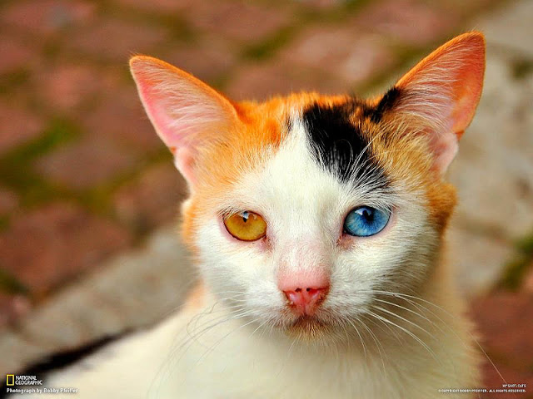
Mutations
Mutations are traits that ARE in the DNA of an organism that ARE NOT present in the DNA of the parents.

Mutations are traits caused by genetic accidents or mistakes in copying DNA. These traits can be beneficial, harmful, or neutral.

These traits can be passed on to future generations, though harmful mutations usually are not passed on because the organism affected will be less likely to reproduce.

Physical Traits can be both:
- Inherited

And

- Acquired

Behavioural Traits can be both:
- Inherited

And

- Acquired

Some traits are a combination of both!
Example: Skin color is partly inherited and acquired

