Static Equilibrium Ladder Problems
Warm up Question:

A uniform ladder of mass m=40kg and length l=10mis leaned against a smooth vertical wall. A person of mass M=80kg stands on the ladder a distance from the bottom, as measured along the ladder. The foot of the ladder is from the bottom of the wall. What is the force exerted by the wall on the ladder? What is the normal force exerted by the floor on the ladder?
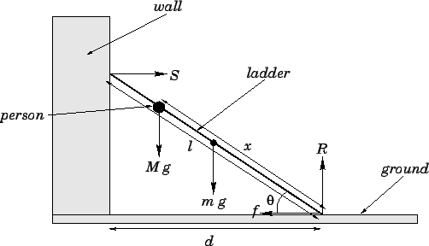

Real Challenge Problem
A ladder is leant against the wall. The coefficient of the static friction μ_{sw} between the ladder and the wall is 0.3 and the coefficient of the static friction μ_{sf} between the ladder and the floor is 0.4. The centre of mass of the ladder is in the middle of it. Find the minimum angle that the ladder can form with the floor not to slip down.

