Snells Law

The index if refraction is defined as a ratio of the average speed of light through a medium divided by the speed of light through a vacuum.
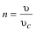
“n” is the index of refraction, “v” is the average speed of light through a medium, and v_{c} is the speed of light through a vacuum. The speed of light is 3.00x 10⁸ m/s in a vacuum.
All angles in optics are measured with respect to the line normal to the surface.
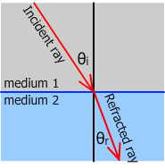
Because of the duality nature of light, it can be said that it travels in rays or waves. For this unit we are looking at the ray properties of light. The ray of light that hits a surface is called the “incident” ray. The angle the incident ray makes between the normal line and the ray called the incident angle. The Ray that bounces off a surface is called the “reflected” ray. The ray that travels to the other side of the surface is called the “refracted” ray. "To refract" means "to bend." The line separating the two mediums is called the “boundary.” “Medium” is another name for the material light travels through.
Snell’s Law mathematically states:
Where is on one side of the boundary and is for value on the other side on the boundary

Purpose: To use Snell's Law to determine the index of refraction (n) of a piece of glass and to use it to find the speed of light in that glass.

Procedure:
- Place your rectangular prism in the middle of the paper.
- Use a sharp pencil to outline your prism.
- Remove the glass from the paper.
- Use a protractor to draw a line that is normal to the clear edge of your rectangle (near the middle).
- Turn on the ray box and place it on the paper so the line of light is aimed at the intersection of the normal line and the prism tracing.
- Trace the ray of light with your pencil. Use a ruler to be as exact as possible.
- Place the prism back onto the paper in its traced location. Make sure its edge is perpendicular to the normal line.
- Trace the light ray that is exiting from the other side of the prism.
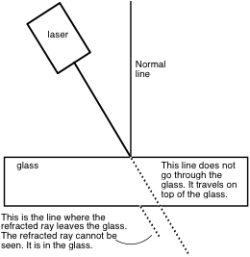
- Connect your incoming ray (incident ray) with the ray leaving the other side of the prism. The connection is the refracted ray.
- Use the protractor to measure the angle from the incident ray and the normal as well as the refracted ray and the normal. Record it in your table.
- Repeat this experiment for five different incident angles.

