Slinky Wave Lab
Background
A wave can be described as an energy disturbance that travels through a medium from one location to another. Waves, simply put, are energy moving from one place to another. As the wave moves through the medium (water, slinky, air), energy is being passed from one particle to the next. Waves occur around us every day. Some common places we experience waves are in sound, light, water, and earthquakes.
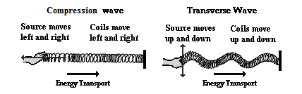

In addition to being a great toy, the Slinky is an excellent device for creating and studying waves. A slinky can easily demonstrate the two basic types of waves, longitudinal and transverse. In a compression wave the particles move parallel to the direction the wave is moving. In a transverse wave the particles move at right angles to the direction of wave travel.
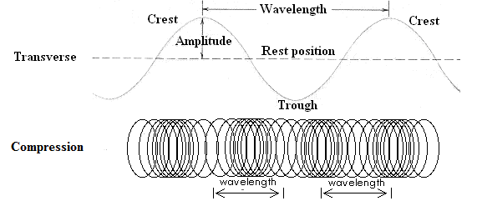There are three basic characteristics used to describe waves.
- Frequency – The number of waves produced in a given time period. This is usually measured in waves per second called Hertz (Hz).
- Wavelength – The length of a wave. This can be measured easily from crest to crest or from trough to trough.
- 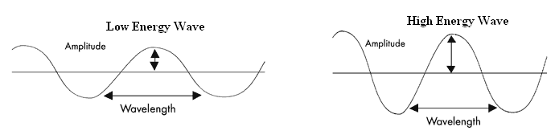Amplitude – The height or depth of a wave. The amount of energy carried by a wave is related to amplitude. A high energy wave is characterized by high amplitude; a low energy wave by low amplitude.
Materials:
Slinky, pencil, timer

Purpose:
The purpose of the lab is to study the types of waves and their properties using a slinky.

Procedure:
- Select lab partners and gather the lab materials.
- On a smooth floor, stretch the slinky out between you and your partner. (Caution – Do not over stretch the slinky!)

- 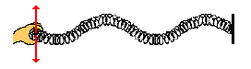Move one end of the slinky back and forth on the floor repeatedly (see diagram below). Observe what happens as you vary the rate at which your hand moves or vibrates.

- You will try to measure the frequency of the waves being made.
  - One person will move the slinky at a moderate rate
  - The one holding the other end of the slinky will count the number of crests that reach their hand
  - The third person will time for 10 seconds.
  - Get three tests and calculate the frequency. Don’t forget your units.

Number of Crests | Time | Frequency
Average Frequency

- Next create a series of waves by moving your hand towards and away from your partner (see the diagram below). Observe this wave and how it travels.

- Answer the questions on the answer sheet.

Slinky Wave Lab - Question Sheet
Questions:

- What is a wave?

- Label the diagrams below with the appropriate wave type.
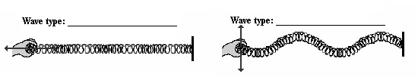
- Identify the parts of the wave below
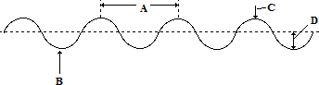

A.______________________
B.______________________
C.______________________
D.______________________

- What happens to the frequency of the waves when you increased the rate of vibration (how fast your hand moved back and forth).

- What happens to the wavelength when you increase the rate of vibration (how fast your hand moved back and forth).

- What is the relationship between wavelength and frequency?

- Are the waves created in step 3 transverse or compression?

- Are the waves created in step 5 transverse or compression?

- For each wave produced did any of the spring coils actually travel from one end of the slinky to another?

- If the wave coils did not travel than what did?

