Science 10 Motion Unit Review

Conceptual Questions

- Explain the difference between uniform motion and non-uniform motion.

- What is the difference between a vector quantity and a scalar quantity?

- What information can you obtain from a position-time graph?

- If you initial position and final position are the same, what is your displacement?

- If a position-time graph has a slope of zero, how would you describe the motion of the object described by the graph?

- Give an example when an object’s average velocity is zero but its average speed is not zero.

- When an object is moving at a constant positive velocity, what would its position-time graph look like?

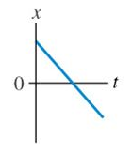

- Describe the motion of the following position-time graph.
- Which position-time graph represents the motion shown in the diagram?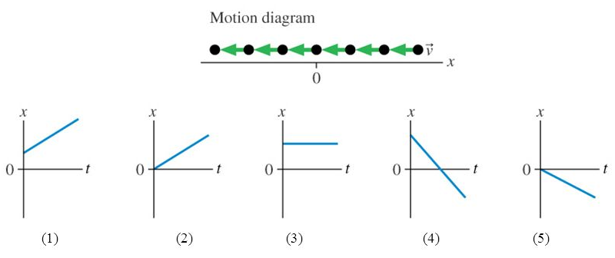

- What information can you get from a velocity-time graph?

- Draw the velocity time graph of an object thrown upward and accelerated by gravity.

Application Problems:

- A boat took 250 seconds to travel 2300m north. What was the boat’s average velocity?

- Convert 210m/s into km/h. Convert 78km/h into m/s.

- If you drive your car with an average velocity of 34m/s N, what would your displacement be if you drove for 1300s?
- An airplane flies with an average velocity of 780km/h south for 6.5 hours. What would the plane’s final position be if its initial position was 1200km north of a special marker.

- A train’s initial velocity is 50km/h East. If its velocity changes to 60km/h East, what is the change in velocity of the train?

- A car moving west at 20m/s strikes a concrete wall and rebounds to the east at 2m/s. What is the car’s change in velocity and the direction of the acceleration?

- A stationary skier starts to ski down the hill with an average acceleration of 3.4m/s² for 15s. What is the skier’s final velocity?

- How muc time is required to accelerate from 35m/s South to 55m/s North with an acceleration of 8m/s² North?

- The velocity-time graph represents the motion of a car. Read the graph and answer the questions a)-d). 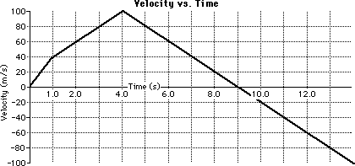

  - During which time interval was it moving the fastest?

  - At what time(s) was its velocity 60m/s North?

  - During which time interval was it slowing down?

  - Calculate the average acceleration for the following time intervals:
0-1s, 1-4s, 4-9s, 9-14s

- A skateboarder is moving with a velocity of 5m/s East. If his velocity doubles in the same direction in 5 seconds, what is his acceleration?

- A rock is thrown into the air with an initial velocity of 15m/s up. What is the velocity of the rock 0.5 seconds later?

- You dropped a ball off a building. The ball’s velocity when it reached the ground was 40m/s down. How long did it take to reach the ground?

