Pinhole Camera Lab

Purpose: To investigate the properties of a pinhole using the concepts of ray optics.

- Set up the camera as directed by the teacher.

- Before the candle is lit:
Make a prediction on what it will look like on the screen:

_______________________________________________________________________________

_______________________________________________________________________________

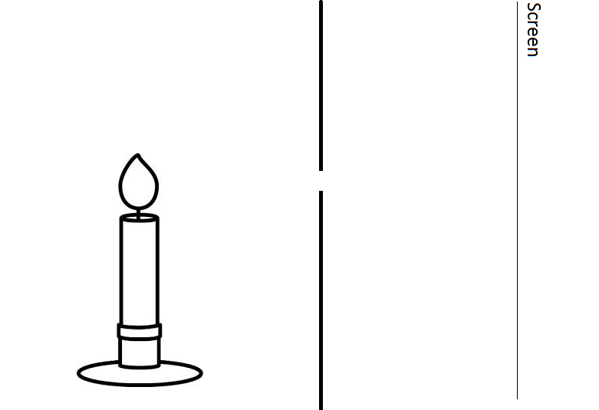

- Move the candle to the side as seen below.
Make a prediction on where the image will move:

_______________________________________________________________________________

_______________________________________________________________________________

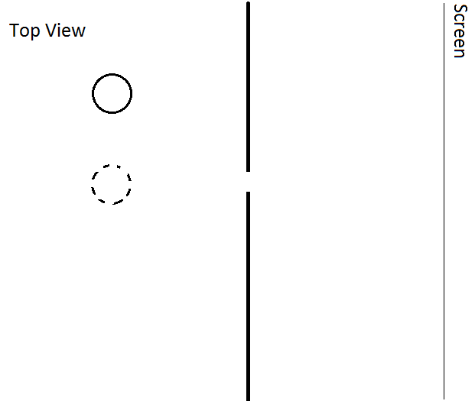

- Move the candle back to the middle. Move it closer to the screen.
Make a prediction on what the image will do:

_______________________________________________________________________________

_______________________________________________________________________________

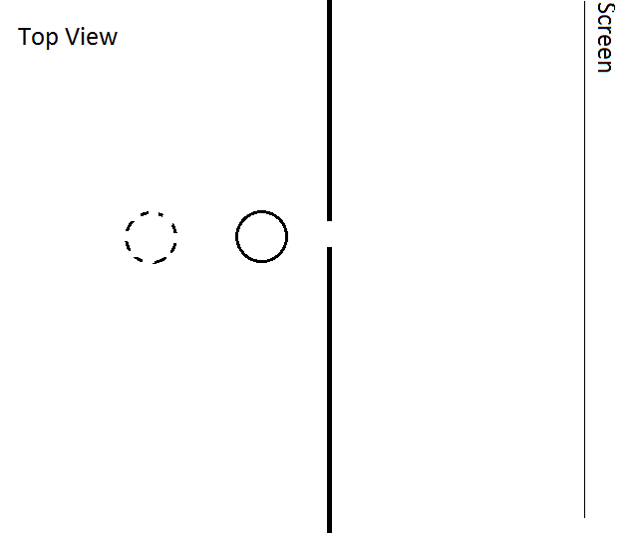

- Move the candle further away from the screen.
Make a prediction on what the image will do:

_______________________________________________________________________________

_______________________________________________________________________________

Questions:

- What relationship (with the position of the candle) did you find with the:
  - Size of the image?

  - Brightness of the image?

  - Left/Right relationship?

- What does the pinhole do to the orientation of the image? What would the “F” below look like on the screen of a pinhole camera?

F

