Physics 11 Momentum and Impulse Review

Level 1 Problems

- Determine the momentum of …
  - an electron (m= 9.1 x10⁻³¹ kg) moving at 2.18 x 10⁶ m/s (as if it were in a Bohr orbit in the H atom).
  - a 0.45 Caliber bullet (m = 0.162 kg) leaving the muzzle of a gun at 860 m/s.
  - a 110-kg professional fullback running across the line at 9.2 m/s.
  - a 360,000-kg passenger plane taxiing down a runway at 1.5 m/s.

- A bicycle has a momentum of 24 kg•m/s. What momentum would the bicycle have if it had …
  - twice the mass and was moving at the same speed?
  - the same mass and was moving with twice the speed?
  - one-half the mass and was moving with twice the speed?
  - the same mass and was moving with one-half the speed?
  - three times the mass and was moving with one-half the speed?
  - three times the mass and was moving with twice the speed?

- According to the Guinness Book of World Records, the fastest recorded baseball pitch was delivered by Nolan Ryan in 1974. The pitch was clocked at 100.9 mi/hr (45.0 m/s). Determine the impulse required to give a 0.145-kg baseball such a momentum.

- Jerome plays middle linebacker for South's varsity football team. In a game against cross-town rival North, he delivered a hit to North's 82-kg running back, changing his eastward velocity of 5.6 m/s into a westward velocity of 2.5 m/s.
  - Determine the initial momentum of the running back.
  - Determine the final momentum of the running back.
  - Determine the momentum change of the running back.
  - Determine the impulse delivered to the running back.

- Kara Less was applying her makeup when she drove into South's busy parking lot last Friday morning. Unaware that Lisa Ford was stopped in her lane 30 feet ahead, Kara rear-ended Lisa's rented Taurus. Kara's 1300-kg car was moving at 11 m/s and stopped in 0.14 seconds.
  - Determine the momentum change of Kara's car.
  - Determine the impulse experienced by Kara's car.
  - Determine the magnitude of the force experienced by Kara's car.

- You and a friend are standing in the middle of a frictionless ice sheet. Use the Law of Conservation of Momentum to explain how you could get to the edges.

- While playing basketball in PE class, Logan lost his balance after making a lay-up and colliding with the padded wall behind the basket. His 74-kg body decelerated from 7.6 m/s to 0 m/s in 0.16 seconds.
  - Determine the force acting upon Logan's body.
  - If Logan had hit the concrete wall moving at the same speed, his momentum would have been reduced to zero in 0.0080 seconds. Determine what the force on his body would have been for such an abrupt collision.

Level 2

- A 92-kg fullback moving south with a speed of 5.8 m/s is tackled by a 110-kg lineman running north with a speed of 3.6 m/s. Assuming momentum conservation, determine the speed and direction of the two players immediately after the tackle.

- The city police are in pursuit of Robin Banks after his recent holdup at the savings and loan. The high speed police chase ends at an intersection as a 2080-kg Ford Explorer (driven by Robin) traveling west at 32.6 m/s collides with a 18400-kg garbage truck moving east at 12.4 m/s. The Explorer and the garbage truck entangle together in the middle of the intersection and move as a single object. Determine the post-collision speed and direction of the two entangled vehicles.

- Bailey is on the tenth frame of her recent bowling competition and she needs to pick up the last pin for a spare and the first place trophy. She rolls the 7.05-kg ball down the lane and it hits the 1.52-kg pin head on. The ball was moving at 8.24 m/s before the collision. The pin went flying forward at 13.2 m/s. Determine the post-collision speed of the ball.

- Polly Ester and Ray Ahn are doing the Elastic Collision lab on a low-friction track. Cart A has a mass of 1.00 kg and is moving rightward at 27.6 cm/s prior to the collision with Cart B. Cart B has a mass of 0.50 kg and is moving leftward with a speed of 42.9 cm/s. After the magnetic repulsion of the two carts, Cart A is moving leftward at 10.1 cm/s. Determine the post-collision speed and direction of cart B.

- Abbey and Mia are in the basement playing pool. On Abbey's recent shot, the cue ball was moving east at 82 cm/s when it struck the slower 5-ball moving in the same direction at 24 cm/s. The 5-ball immediately speeds up to 56 cm/s. Determine the post-collision speed of the cue ball.

- Rex (m=86 kg) and Tex (92 kg) board the bumper cars at the local carnival. Rex is moving at a full speed of 2.05 m/s when he rear-ends Tex who is at rest in his path. Tex and his 125-kg car lunge forward at 1.40 m/s. Determine the post-collision speed of Rex and his 125-kg car.

Level 3

- A 72-kg boy and a 48-kg girl, both wearing ice skates face each other at rest on a skating rink. The boy pushes the girl, sending her eastward with a speed of 6.8 m/s. When the impulse is completed, the boy and girl are a distance of 1.4 meters apart. Determine the distance of separation between the boy and the girl 5.0 seconds after the impulse is completed.

- A physics student hurls a 315-gram ball directly into a 3.54-kg box which is at rest on a table top. The baseball strikes the box with a pre-impact speed of 54.1 m/s. The box is filled with towels to help absorb the blow and effectively catch the ball. The coefficient of friction between the box and the table is 0.714. Determine the distance which the ball and box slide across the table after the collision.

- Use the diagram below to find the unknown value of the mass of cart C.
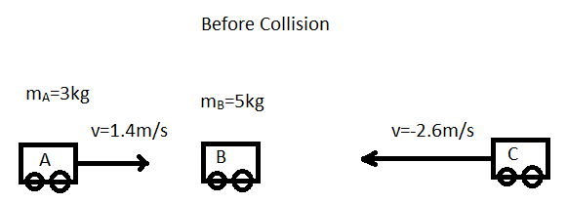

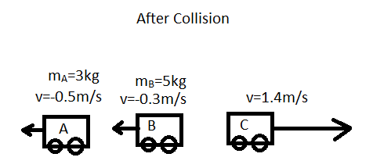

Answer Key

- a) 1.98×10⁻²⁴kgm/s b) 139kgm/s c) 1012kgm/s d) 540000kgm/s
- a) 48kgm/s b) 48kgm/s c) 24kgm/s d) 12kgm/s e) 36kgm/s f) 144kgm/s
- 6.525Ns
- a) 460kgm/s E b) 205kgm/s W c) 664kgm/s W d) 664Ns W
- a) 14300kgm/s b) -14300Ns c) -1.02×10⁵N

- a) 3515n b) 70300N
- 0.68m/s S
- 7.83m/s E
- 5.4m/s
- 32.5cm/s right
- 50cm/s
- 0.61m/s
- 58m
- 1.4m
- 1.8kg

