How Things Live Underwater

What an individual needs to survive. What a species needs to survive.

Breathing Underwater

Fish are able to breathe underwater because of ____________________.

Gills

Gills function the same way as lungs do:
Lungs work by:

In fish the deoxygenated blood is sent directly to a group of specialized cells called the _________________. Seawater is forced across the ________________ and dissolved oxygen in seawater is taken in by the blood vessels and CO₂ is kicked out.

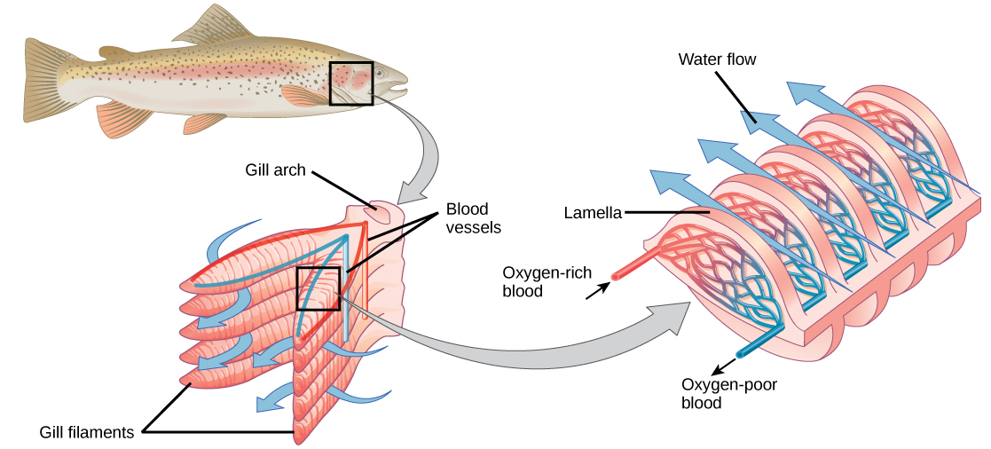

Gills are built like a car radiator, with a series of _________ that weave back and forth. This increases the ___________________ of the gill that can be exposed to the water. This is needed in the ocean as there is about _____________________ of dissolved oxygen in water (compared to _____________________ on land). This means the more surface area the better.
Fish also are __________________________, which helps reduce the amount of oxygen they require.

Fish in the ocean are also exposed not just to the oxygen in the water, but also the ____________________.

- The ocean is _________________________ (saltier than the fish). Diffusion will make the fish absorb the salt.
  - In the gills are extra cells called _________________ cells. They allow the fish to expel excess salt.

- Fresh water is ________________________ (less salty than the fish). This means the salt will be dissolved out of the fish.
  - Freshwater fish have far fewer _______________ cells.
  - Freshwater fish also have the ability to make their __________ very dilute so they can still keep their salt levels high enough to live.

How do mammals hold their breath for so long?

Imagine holding your breath while chasing down a giant squid (Architeuthis dux)—multi-tentacled monsters wielding suckers lined with tiny teeth—in freezing cold water, all in the dark. Sperm whales (Physeter macrocephalus) do this day in and day out.

Many aquatic mammals that can dive have special mechanism that help them _______________________, _________________________, and _______________________ from their extremities to head to the brain, heart and muscles when starting a dive.
This doesn’t account entirely for their ability to hold their breath for so long.
- ____________________ can hold their breath for ____________. They have to rely on internal stores of oxygen.

It has recently been discovered that diving mammals have large quantities of a protein called __________________.
- ____________________ is a protein that binds oxygen in the muscles. Diving animals can have up to ten times the amount of myoglobin in their muscles compared to land animals.

The downside packing too many proteins is dangerous because they can clump together if they get too close. This can cause _______________ or _____________________.

