As a group, come up with a strategy to solve the given problem. No numbers are needed nor given. Use key ideas and the Law of Conservation of Energy. You will have to present your strategy to the class:
- Use a diagram
- Do simply state the equations you will use, you must communicate using the theory and laws covered in class.

An unpowered cart, starting at point A has to roll down through point B then reach point C. If you can measure the heights of the points, how would you figure out how fast the cart must be going at point A to only just make it to point C?
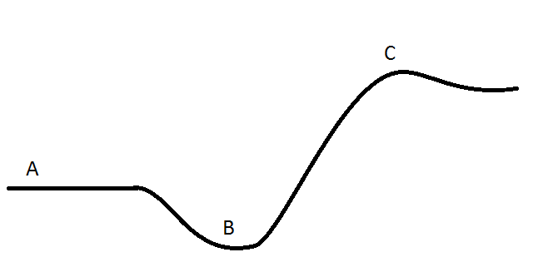

As a group, come up with a strategy to solve the given problem. No numbers are needed nor given. Use key ideas and the Law of Conservation of Energy. You will have to present your strategy to the class:
- Use a diagram
- Do simply state the equations you will use, you must communicate using the theory and laws covered in class.

A box will slide down a slope and experience an amount of friction. Given you can measure the dimensions of the slope, the force of friction and the mass of the box, how would you measure the velocity of the box?

As a group, come up with a strategy to solve the given problem. No numbers are needed nor given. Use key ideas and the Law of Conservation of Energy. You will have to present your strategy to the class:
- Use a diagram or physical examples
- Do simply state the equations you will use, you must communicate using the theory and laws covered in class.

Explain how, though they are scalars, Potential Energy can be negative, yet Kinetic Energy cannot.

As a group, come up with a strategy to solve the given problem. No numbers are needed nor given. Use key ideas and the Law of Conservation of Energy. You will have to present your strategy to the class:
- Use a diagram
- Do simply state the equations you will use, you must communicate using the theory and laws covered in class.

Two blocks are attached using a frictionless, massless, pulley and string. If the table has a measureable coefficient of friction and the mass of the boxes are measureable, how would you determine the velocity of the systems after the hanging box has dropped a specified amount?

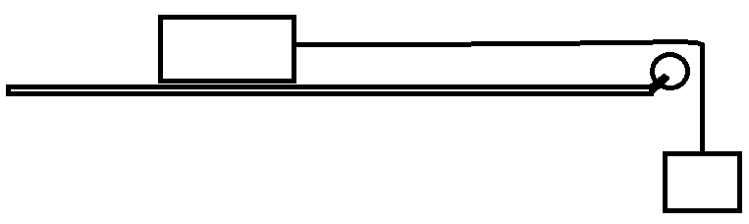

As a group, come up with a strategy to solve the given problem. No numbers are needed nor given. Use key ideas and the Law of Conservation of Energy. You will have to present your strategy to the class:
- Use a diagram
- Do simply state the equations you will use, you must communicate using the theory and laws covered in class.

Two blocks are attached using a frictionless, massless pulley and string. If the masses of the boxes is measureable, how would you find the velocity of the system after the boxes have been displaced a certain amount?

