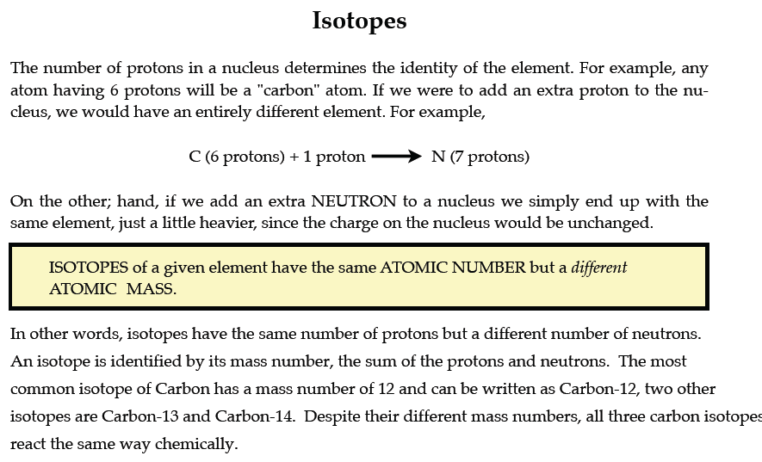
PART I. Answer the questions based on the above reading.

1. What is an isotope? _____________________________________________________________

________________________________________________________________________________

2. What does the number next to isotopes signify? _______________________________________

________________________________________________________________________________

3. How can you tell isotopes of the same element apart? __________________________________

________________________________________________________________________________

PART II. For each of the following isotopes, write the number of protons, neutrons, and electrons. Assume all atoms are neutral.
 | Carbon-12 | Carbon-13 | Carbon-14
# of protons
# of neutrons
# of electrons

 | Chromium-58 | Chromium-63
# of protons
# of neutrons
# of electrons

 | Nitrogen-15 | Nitrogen-20
# of protons
# of neutrons
# of electrons

 | Sulfur-23 | Sulfur-25
# of protons
# of neutrons
# of electrons

 | Selenium-50 | Selenium-55
# of protons
# of neutrons
# of electrons

 | Sodium-12 | Sodium-20
# of protons
# of neutrons
# of electrons

PART III. Fill in the isotope names and any missing information on the chart. Use your periodic table and the information provided. Assume all atoms are neutral.

# of protons | 25
# of neutrons | 17 | 15
# of electrons

# of protons | 32
# of neutrons | 30 | 32
# of electrons

# of protons
# of neutrons | 48 | 51
# of electrons |  | 46

# of protons
# of neutrons | 113 | 111
# of electrons | 55

 | Iron- | Iron-
# of protons
# of neutrons | 27 | 30
# of electrons

 | Iodine- | Iodine-
# of protons
# of neutrons | 32 | 35
# of electrons

 | Germanium- | Germanium-
# of protons
# of neutrons | 33 | 36
# of electrons

 | -10 | -12
# of protons |  | 6
# of neutrons
# of electrons | 6

 | -54 | -56
# of protons | 24
# of neutrons
# of electrons

 | -22 | -25
# of protons
# of neutrons
# of electrons | 11

