Hydroelectric Energy Production

How does it work?
Hydroelectric power stations use the ________________ energy of falling water to produce electricity.
The amount of energy that can be generated is directly related to the amount of ______________ change that the water goes though, called ___________ ________________________.
Most power plants manipulate the force of the water with ________. Man-made dams retain massive amounts of water in ______________________, and form drastic drop-offs that enhance the kinetic energy of falling water. These dams, however, require a large amount of __________________ upriver of the dam.
Dams also allow control of how __________ power is made and _____________ it is made.

- When power is needed the _________________ of the dam are opened

- Water is funneled into a pipe known as the _____________________ and it gains pressure as it runs down the penstock’s gradient.

- The water strikes an electricity-generating ___________________ and forces the blades to turn.

- The spinning turbine turns the shaft attached to the ___________________ which moves a magnet through a coil of wire and produces electricity.
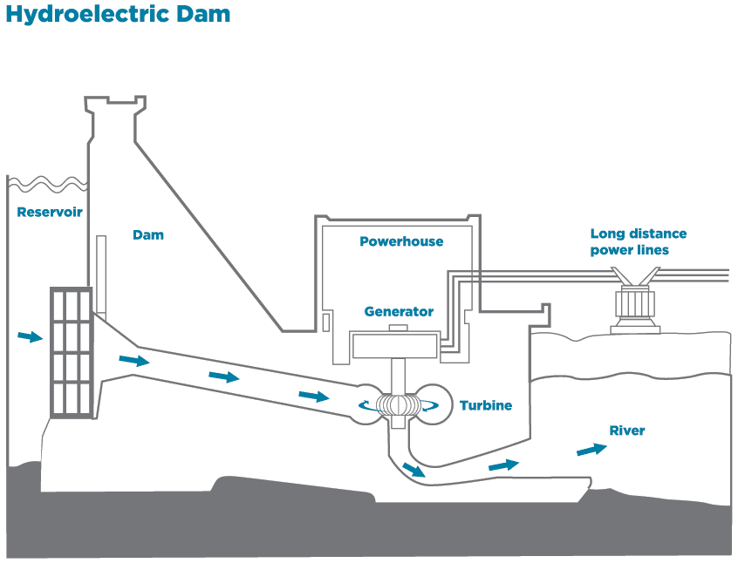

Hydropower is extremely efficient; most modern stations can convert over ________ of available energy into electricity.
(source: www.energybc.ca/largehydro.html#footnote-4)

Storage in hydropower is easier than in many other forms of energy production. Storing extra _______________ in the reservoir is a simple way to store potential energy. When more energy is needed more water can be diverted into the turbines and more energy is produced.

Pros and Cons of Hydro Electricity
Pro | Con

The Largest Sources of Hydroelectricity Around the World

China
- China has many rivers, lakes and mountains. Largest potential for hydro in the world.
- Currently produces the most electricity via hydro in the world
- Hydro accounts for ________ of their electricity production

Brazil
- Has nearly ____ times the potential of hydroelectric production as Canada
- Second largest producer of hydro in the world
- Has increased small scale hydro generation

Canada
- Third highest estimates potential hydroelectric production in the world.
- Roughly only _________ of possible generation is being used.

(Source: ‘Used by permission of the World Energy Council’ www.worldenergy.org)
How much is made in BC
(Source: https://www.bchydro.com/content/dam/BCHydro/customer-portal/documents/corporate/accountability-reports/financial-reports/annual-reports/bc-hydro-annual-report-quick-facts-june-2014.pdf)

BC Hydro reports that nearly the maximum production capability of current resources _________________________is produced every second.

It sells slightly over ____________________ of that as trade to other countries and of the domestic product about ______________ of it is used by residents of BC.

On average we get _____________________________ MJ per day from hydroelectricity in BC.

This means we get _____ bricks of butter from hydroelectricity in BC.

Reflection Questions:

- Research how many people live in BC. Use the estimates in our notes on how much energy BC sells away, and the potential untapped hydro resources in Canada to estimate the maximum number of people BC Hydro can provide energy for.

- Site C dam is a proposed large scale dam in BC that can increase the hydroelectric production in BC by 10%.
  - Research why some people are in favor of building this dam.
  - Research why some people are against building this damn.

