Hooke’s Law

Robert Hooke (1635-1703) calculated the force required to stretch springs

Use this line to measure the force required to stretch the spring in a spring scale:

Distance Stretched

Force Required

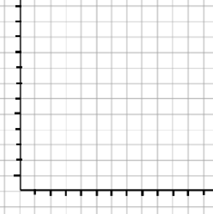
Spring Constant (k):

The force exerted by a spring can be calculated by:
Where:
k=

Δx=

Ex. A truck (4500kg) has 4 springs as suspension. When the truck is at rest, the suspension is compressed by 3cm. What must the spring constant be for any replacement suspension parts?
Ex. A spring is compressed 62cm from its equilibrium position. It has a k=0.95N/m. How much force is the spring under?
Ex. An 80kg mass is hanging at rest from a spring (k=970N/m). How far is the spring stretched from its equilibrium position?

