Heating and Cooling

What Things Would We Heat or Cool in our House?

Heating or Cooling things can be calculated by using the formula:

$$Energy=Heat Capacity×Volume ×Change in Temperature$$

Heating Water

Where would we use the most water?

Water has a heat capacity of $4180\frac{J}{kg∙°C}$ .

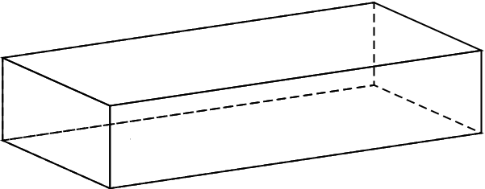
Let’s begin by estimating the energy used to heat a bath. How big is a bath?

Volume = LxWxH

There are __________ L of water in a bath

To find the change in temperature we need to know:
How hot are our baths?

How cold is water from the tap? (before it goes to the water heater)

Now let’s calculate the energy used to draw a bath.

Showers take roughly one third the amount of water a bath would take. So, a shower would take ___________ of energy.

Other Water Estimates:

Dish Washing: Energy-Star rating appliances use about __________MJ per load

Clothes Washing: Energy-Star rating appliances use about __________ MJ per load

Food

From the ”Energy Use Estimation Worksheet”

Electrical Device | Watts | × | Hours of Daily Use | × | Days Used per Week |  | ÷ | 7 | = | Avg. Daily Watt-Hours
Fridge |  | × |  | × |  |  | ÷ | 7 | =
Oven |  | × |  | × |  |  | ÷ | 7 | =
Stove |  | × |  | × |  |  | ÷ | 7 | =
Freezer |  | × |  | × |  |  | ÷ | 7 | =
 |  |  |  |  |  | Total

Air

During summer, we don’t use our heaters. During winter, we probably use our heaters. A personal heater uses about 1000J each second.

So, for our three big things that we heat or cool we have, each day uses:

- Water _____________MJ

- Food ____________MJ

- Air ____________MJ

Total Energy use on Heating/Cooling per day ________________MJ

Or ________ bricks of butter.

