Force Analysis Lab – Block and Mass

Purpose: To determine the mass of a block when pulled by a hanging mass via a pulley.

Materials:

- String
- Mass Set
- Wood board
- Pulley
- Block
- Spring Scales
- Laptop with Tracker program

Procedure:
- Determine the force of friction of the block on the board by pulling the block at a constant velocity with a spring scale.

- Attach the pulley to the board and tie a length of string to the block.

- Set up the board and materials as seen in the diagram

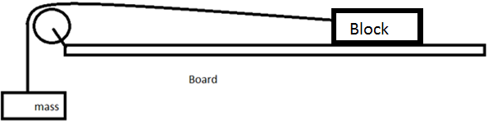
- Release the mass hanging from the pulley and let it pull the block. Record the movement of the block using a video recording device
  - Be sure to catch the block before it falls off the board!

- Repeat the experiment at least 3 times.

- Using the Tracker program, make a velocity time graph for each run. Use a best fit line to determine the acceleration of the system.

Analysis:
- Draw a clear Free Body Diagram for the system.
- Using the acceleration found from the graphs, calculate the mass of the block. Show all work.
- Determine the tension of the string. Show all work.
- What possible sources of error may contribute to uncertainty in your results?

