Electrical Energy and Power Worksheet

- The following circuit consists of a power supply an ammeter and a light bulb.
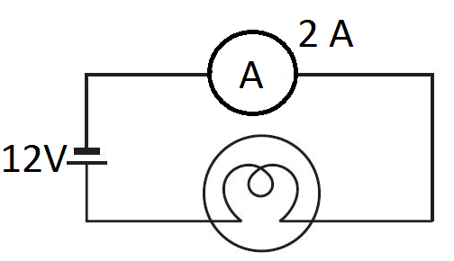
  - Calculate the power used by the light bulb.

  - Calculate the energy used after 15 hours of operation (in kWh).

- Wasteful Willis leaves appliances on for no good reason.
  - Willis is studying in the evening. He uses his desk lamp that runs off of 120V and has 0.5A of current running through it. How powerful is his lamp?

  - How much energy did Willis use for his study session from 7:30pm to 10:00pm?

  - Willis didn’t turn off the lamp before he went to bed. How much energy does the lamp use from 10:00pm until 8:00am when he gets up?

  - How much money would that cost him if electricity is 10¢ per kWh?

- Willis is really good at multitasking. Every day after school, Willis turns on his computer (450W), iPad (100W), cell-phone charger (50W), desk lamp (60W), television (200W), game console (115W) and stereo (75W). If he uses all these things for 4 hours each day after school, how much is it costing him in electricity per week?

- Sam really loves the movie trilogy “The Lord of The Rings”.
  - Calculate the power used by a TV that requires 110V and 3A of current.

  - Calculate the amount of energy used to watch the extended editions of all three movies. (Run time is 11hours and 22 minutes)

  - How much did the energy cost Sam to watch his favorite movies? (10¢ per kWh)

- You probably don’t like vacuuming. You’re going to try to get out of it by telling your parents that running the vacuum is too expensive.
  - Calculate how much power is needed to run the vacuum if it takes 120V and 10A of current.

  - If it takes you 2 hours and 30 minutes to vacuum the house, how much energy will the vacuum use?

  - How much money will your parents pay in energy costs for this usage?

  - Do you think this excuse will work?

