Connected Masses

As we might have seen, we can connect one mass to another to influence its motion. In these cases, direction, friction, and other values we’ve used may not be as simple to apply.
When you have connected masses these problem solving steps are critical:
- Have a

- Make sure you understand how moving ________ _______________ will move the ________________

- Use F_{Net} = and F_{Net}=

- Be comfortable switching between thinking about the __________________ as a whole and thinking about the ________________________ ______________
Ex. A 500g cart on frictionless wheels is attached by a rope to a 300g block sitting on the ground with a coefficient of friction of 0.33. A 2N force is pulling the cart to the left. What is the acceleration of the system?
Ex. A 1000kg elevator has a 1200kg counterweight. If a 75kg person stepped into the elevator, what force will the motor have to exert to raise the elevator at a constant velocity?
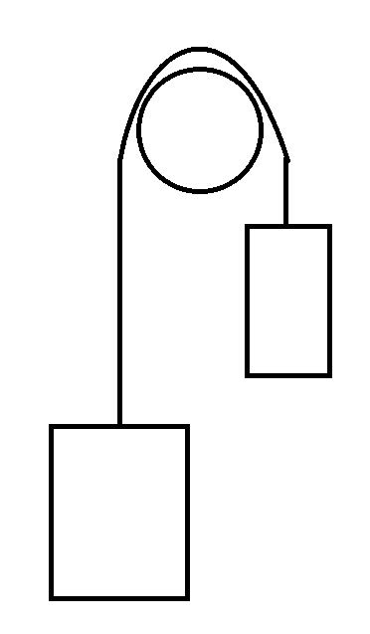

Ex. Two blocks are suspended from the ceiling from springs as shown in the diagram. Determine how far spring 2 is stretched. Determine how far spring 1 is stretched.
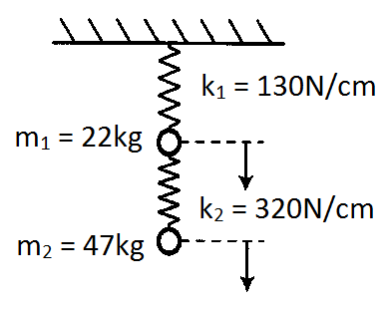

Ex. Two blocks are attached and are accelerating as shown in the diagram. Determine the unknown mass of the hanging block.
