Christmas Themed Force Challenge Problems

- Three elves are messing around with some ropes and pulleys. They end up in a situation like the one shown in the diagram.
  - What is Steve’s mass?

  - Santa is super mad, toy submission deadlines were four days ago and these goof-offs are still late. He picks up and tosses Steve (no longer attached to the string) with a force of 370N. What is Steve’s acceleration after Santa tosses him?

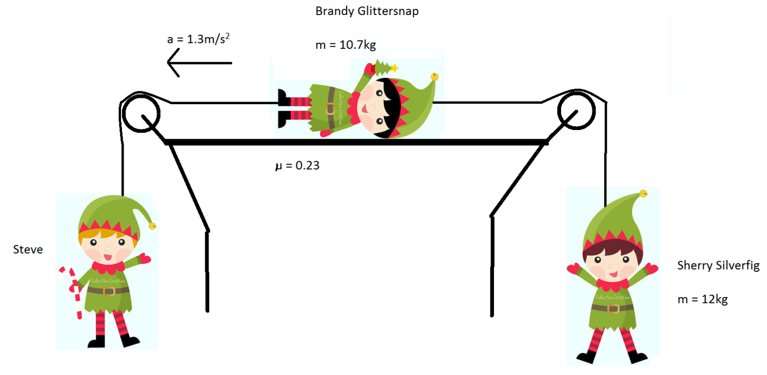

- An astronaut decides to deck the cosmos with some ornamental balls (in space!). The balls all have a diameter of 8cm.
  - Draw the free body for each ball.
  - Find the net force on each ball.
  - Find the acceleration of each ball.

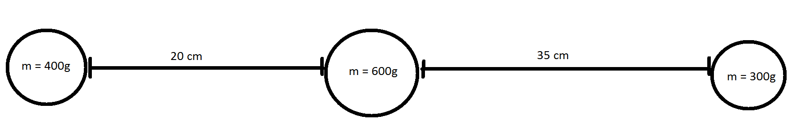

- An oversize 33kg present is currently in the chimney. The coefficient of friction between the present and the walls is 0.77. The normal force between one wall and the present is 230N Will the present move?

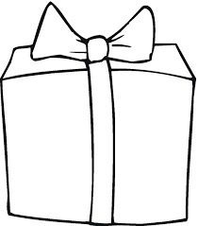

If the present moves | If the present doesn’t move:
What is the acceleration?

What force is needed to make it stop?  In which direction? | What force is needed to make it move?  In which direction?

