Chapter 6 - The Eye Review

Part of the Eye | Function
Sclera
Pupil
Iris
Cornea
Lens
Optic Nerve
Retina
Vitreous Humor

What causes your blind spot?

Where, in the eye, is your blind spot?

Why do we not see a blank spot in our vision all the time?

Label the eye diagram
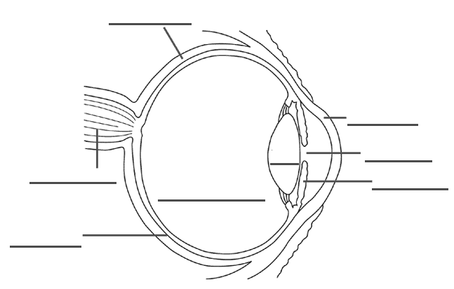
Use a ray diagram to show the image at the back of the eye
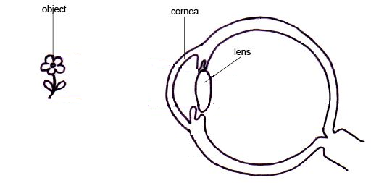

What do rods do? What type of vision are they responsible for?

What do cones do? What type of vision are they responsible for?

How many different types of cones do you have?

What are the types of cones?

Your optic nerve sends what to the brain to be processed?

When a person is farsighted:
-They can see things _____________________
-The image is focused (before/behind) the retina.
-Can be corrected with:

When a person is nearsighted:
-They can see things _____________________
-The image is focused (before/behind) the retina.
-Can be corrected with:

When a person has astigmatism:
-The image is focused __________________________________ the retina.
-Can be corrected with:

Write a definition of blindness in your own words.

Describe:
Snow Blindness

Night Blindness

Colour Blindness

Technologies

Describe the parts of a camera and how they are similar to the parts of the eye.

How is laser light different from light from a light bulb?

How many lenses does a microscopes use. What are the names of the lenses?

Describe how the two different types of telescopes work.

