Energy Conservation and Conversions

The Law of Conservation of Energy

What does this mean?

Converting Energy

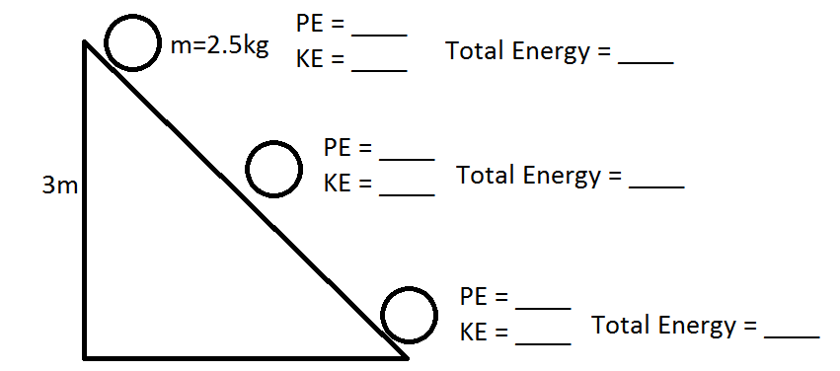

Example
A book is lifted off of the ground by a student.
- What is happening to the energy of the book?

- Where is the energy coming from?

What powers most of our technology currently?

How do we get some of this energy?

What do we do to convert other forms of energy into ____________________?

A computer uses electricity to operate.
- Where does this energy come from?

- Trace the energy back to its original source.

Energy “Loss” – Efficiency

When energy is transformed from one form into another, or from one object into another there some of the energy is “lost”. This means that when energy is converted to a different form, some of the input energy is turned into a ___________________________________ of energy.

Types of Energy Loss

When we experience energy loss, the energy doesn’t actually disappear. It is converted into a form of energy that we ________________________________________. The three most common forms of energy that account for energy loss are:
- ______________________ energy

- _________________ energy

- _________________ energy

Example:
3528J of energy can be put into a hydraulic lift to lift a 300kg cart.
- If there was no energy loss, how high should the cart rise?

- What sorts of energy loss might you observe?

- If 122J of energy was lost, how high would the cart actually rise?

A transfer of energy with no loss is functionally ____________________, unless one is deliberately turning energy into heat (like in a heater). As well, whenever electrical energy is transported through power lines, the energy into the power lines is always more than the energy that comes out at the other end. Energy losses are what prevent processes from ever being 100% efficient.

Efficiency

Efficiency is the measure of how much energy is ______________ compared to how much is _____________.
Output energy is the _____________ of the energy in an object. It is the end result, or what you would see.
Input energy is the amount of energy or effort you try to ____________________ the object. This is how hard you work to move things.

Efficiency formula

Examples:

- Tom puts 315J into moving a cart, but it only gains 275J of energy. How efficient was Tom?

- Jane uses 3000J of energy in an 84% efficient machine. What is the output energy Jane gets?

- A 250kg car uses 12000J of energy to get to a speed of 8m/s. How efficient is the car?

