Viscosity, Adhesion and Cohesion

Vocab – viscosity, adhesion, cohesion, flow rate, surface tension

Viscosity:

Viscosity of a fluid usually due to two factors:

- ____________________________: if the molecules of in a fluid have a ______________ shape, it will be _____________ for the molecules to move past each other.

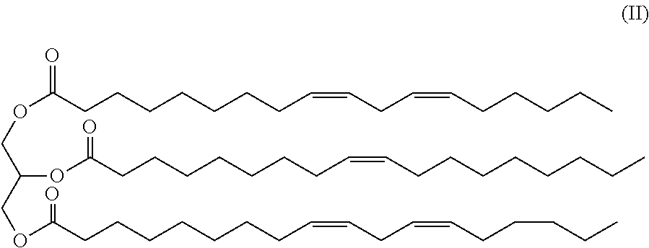
Water Canola Oil

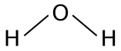
Molecule
Shape:

Viscosity:

- _________________________ between particles: if the particles in a fluid are more ____________ to each other, it will be more _______________ for the particles to move past each other.

You can compare the viscosity of fluids by comparing their _____________. To calculate a flow rate, pour the fluids down a track and time how long it takes for the fluid to flow the full distance. Then _____________ the ______________ of the track by the _____________.

Temperature and Viscosity

Both ___________ and __________ have viscosity, though __________ usually have very little viscosity. Temperature actually effects viscosity differently for ______________ compared to ______________.

Liquids and Temperature:

Gases and Temperature:

Adhesion

Adhesion is the property of a fluid to_______ or _________ to _______________. We can clearly see the property of adhesion with __________. When we get out of the pool when swimming, some water will _________ to us. The adhesion of water is __________ enough to work against the __________________.

Imagine you are in a pool of a fluid that had no adhesion. When you leave the pool all of the fluid would _______________ of right away and you would be ___________ without having to use a ___________.

Water gets its property of adhesion by being a ___________________. This means one end of a water molecule has a slight _____________ ______________ and the other end has a slight ______________ ________________. It exerts an _________________ __________ to pull it to other object.

Glass of water

Cohesion

Cohesion is the property of a fluid to __________ to ___________. If a fluid ______________ to itself strongly it will want to stay as _______________ as much as possible and can form ________ __________ ________, rather than ______________ over the surface it is on.

_____________ __________ is a property of liquid that is determined by how ____________ the liquid is. If a liquid strongly binds to itself it will take more ___________ to break through the ______________ of the liquid. Surface tension can make it appear like liquid surfaces have a _________ _________ or __________________. Some animals and insects rely on surface tension of water to be able to escape from land predators.

Homework p.309 #1-6

